**Home Learning**

**Year 6 – Term 6 Week 3**

**Wb 15th June 2020**

# Reading

# Don’t forget to read for at least 20 minutes each day. It is useful if you can have a book that you read over a series of days so that you can build up your understanding of the story, rather than flicking through a different one every day. This week our focus is Roald Dahl, please choose a favourite or, perhaps one you haven’t read before to re-read. Which do you enjoy the most? Choose a section and practice reading aloud- perhaps you could read to a younger sibling? Or see if a family member would like a story read to them. Think carefully about expression and intonation, particularly if you are on the phone and your audience can’t see you.

# If you have any recommendations for the class, please take a photo of your book review and email them to the office. I know everyone has enjoyed looking at the gallery.

# Speaking and Listening

It is time to make a start on our end of Year celebration! Next week you will be emailed a part to learn

Year 6 will be presenting:

Revolting Rhymes by Roald Dahl

Your job is to learn your lines, rehearse them, rehearse them, rehearse them!

Think about your character…gather any props or costume that you think will enhance the role.

Then, ask a family member to record it for you! Do a couple of takes, then send us the copy you are happy with to the admin address.

We will compile the parts into a big film which will be shared. 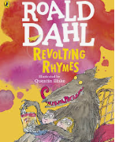

Please read through the rhymes on the website so that you are familiar with them.

Once we have got the speaking parts completed there will be some other jobs to do too. We will need tickets, programs and posters all to be designed.

**Writing**

Do you remember the conventions for writing playscripts?

Can you write a section of a play including any stage directions? You could also write a script for a story you have written or a program you have watched.

|  |  |  |
| --- | --- | --- |
| Success Criteria for Writing a Playscript | | |
| I have set the **scene**, using the **present tense**. |  |  |
| I have written the **names of the characters down the left** side of the page (with a colon)...not in the margin! |  |  |
| I have included several **stage directions** in brackets |  |  |
| I have written extensive, interesting **character dialogue** |  |  |
| I have started a **new line for the next speaker** |  |  |
| I have correctly used **full-stops and capital letters** |  |  |
| I have used **commas** in lists and to separate phrases. |  |  |
| I have used **adverbs** in my stage directions to help the actor know *how to say lines, where to go, and what to do/which facial expression to show.* |  |  |

**Drama-**

<https://www.bbc.co.uk/bitesize/topics/zsn4h39>

This tells you more about plays; you could even act them out.

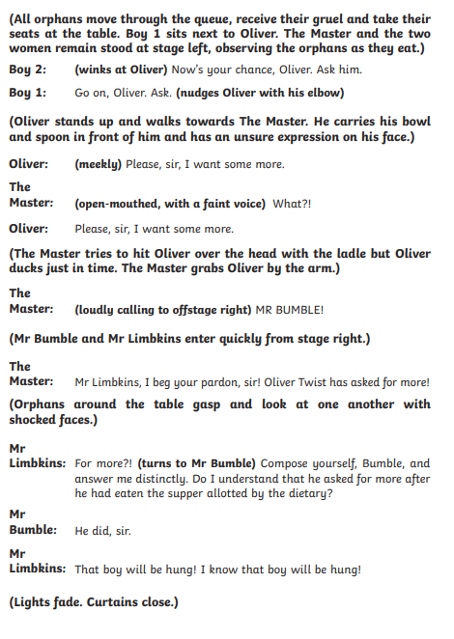

Comprehension

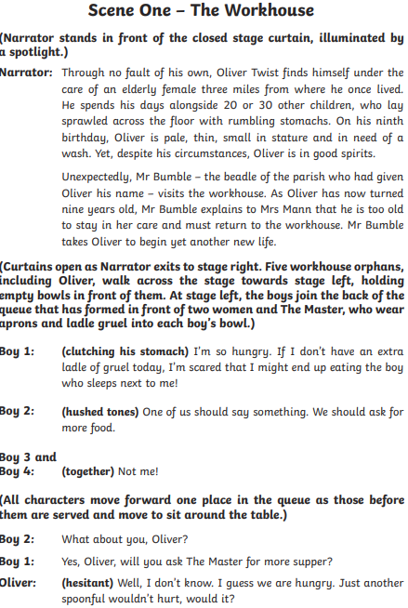

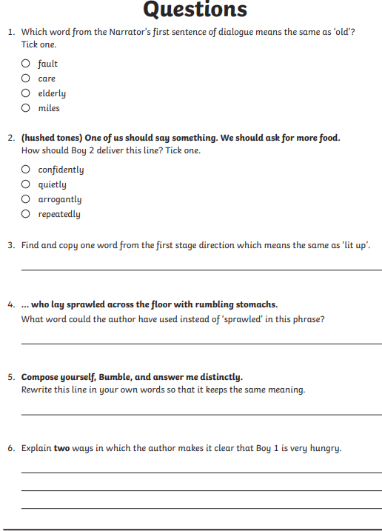

Spelling

First, please put these words in alphabetical order, then try to use them in sentences.

|  |  |
| --- | --- |
| lightning | language |
| interfere | leisure |
| identity | individual |
| immediate | mischievous |
| marvellous | interrupt |

Please also add a couple of your own.

**Maths *This week you will have a choice of a BBC Bitesize lesson, a daily range of fluency and reasoning questions as well as practicing Times Tables on Professor Assessor.***

**Day 1- BBC Bitesize- Simplify Fractions**

<https://www.bbc.co.uk/bitesize/articles/zkkm6v4>

**Day 1 Fluency and Reasoning**

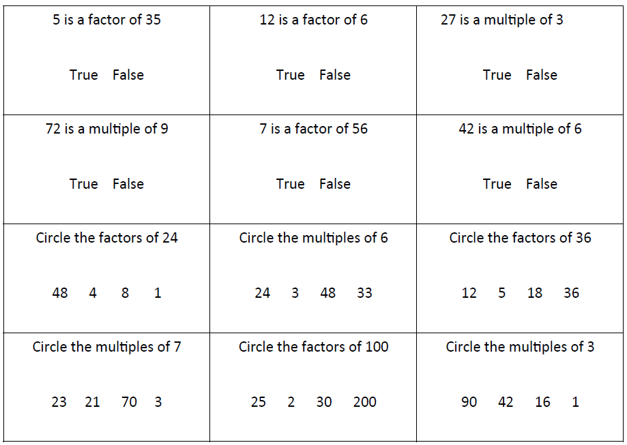

**Day 2- BBC Bitesize- Compare and Order Fractions** <https://www.bbc.co.uk/bitesize/articles/zkk6hbk>

**Day 2 Fluency and Reasoning**

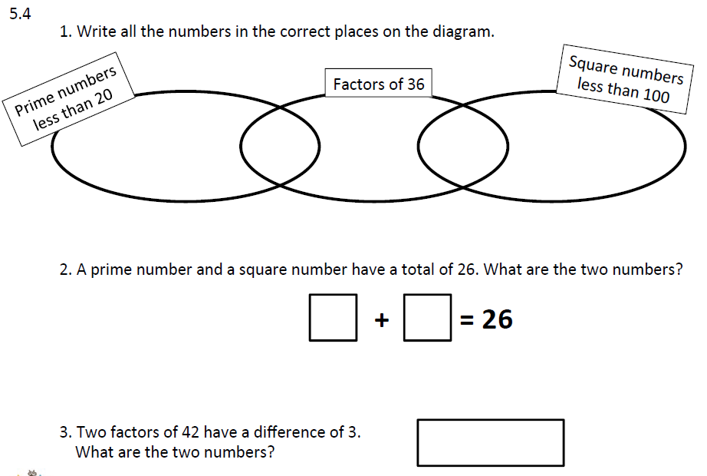

**Day 3- BBC Bitesize-** Add and Subtract Fractions <https://www.bbc.co.uk/bitesize/articles/z7ty382>

**Day 23 Fluency and Reasoning**

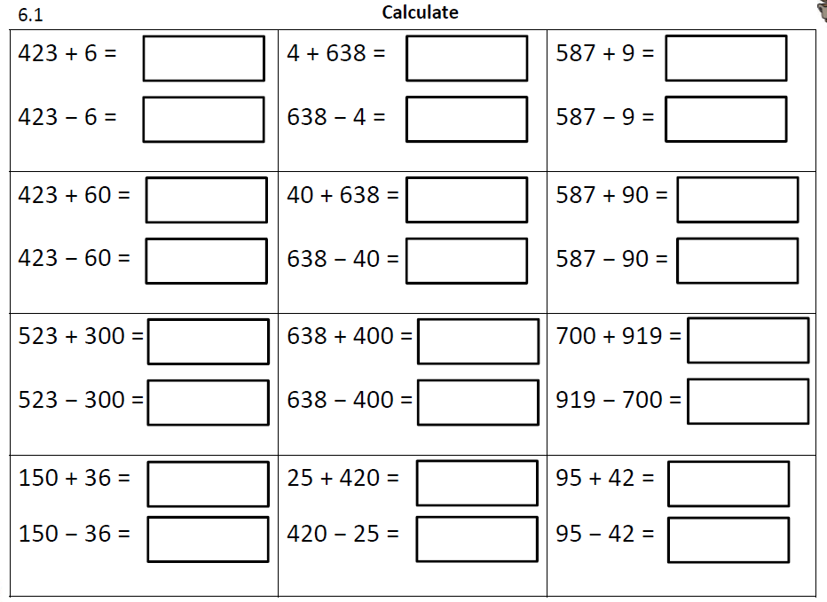

**Day 4- BBC Bitesize- Multiplying Fractions** <https://www.bbc.co.uk/bitesize/articles/zrspscw>

**Day 4 Fluency and Reasoning**

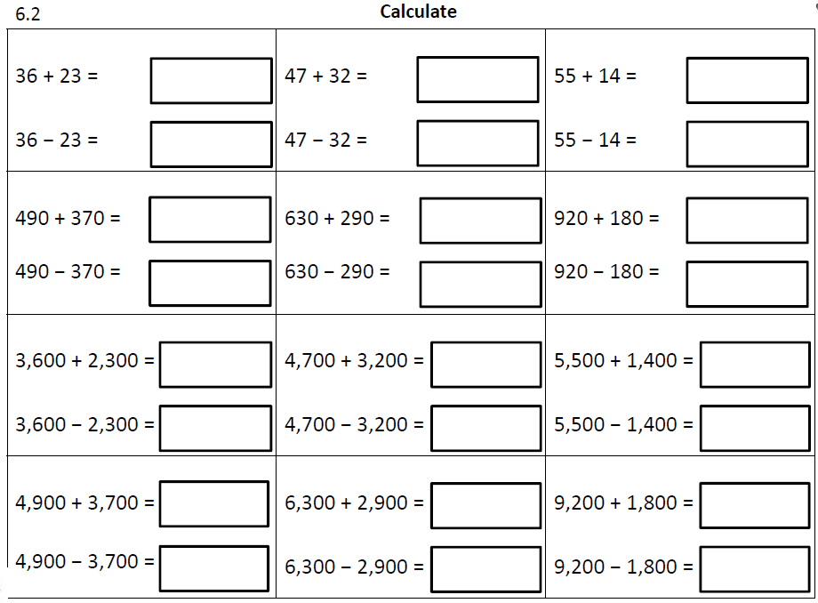

**Day 5- BBC Bitesize- Dividing Fractions** <https://www.bbc.co.uk/bitesize/articles/zhw8wty>

**Day 5 Fluency and Reasoning**

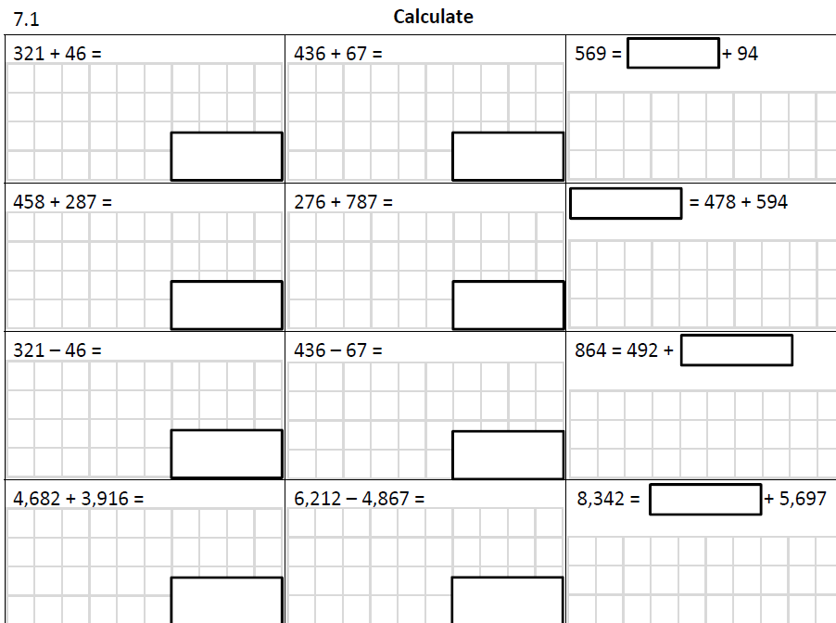

**Religion**

The Baptism of Jesus

This week, we are going to explore one of the most significant moments in the life of Jesus – His baptism. Watch the account by John from the film Jesus of Nazareth (available from YouTube at <http://www.youtube.com/watch?v=_CVXBCfdrF8> )

**The Baptism of Jesus as described in Matthew’s Gospel**

In those days John the Baptist came, preaching in the wilderness of Judea and saying, “Repent, for the kingdom of heaven has come near.” This is he who was spoken of through the prophet Isaiah:

“A voice of one calling in the wilderness,  
‘Prepare the way for the Lord,  
make straight paths for him.’

John’s clothes were made of camel’s hair, and he had a leather belt around his waist. His food was locusts and wild honey. People went out to him from Jerusalem and all Judea and the whole region of the Jordan. Confessing their sins, they were baptized by him in the Jordan River.

John said “I baptize you with water for repentance. But after me comes one who is more powerful than I, whose sandals I am not worthy to carry. He will baptize you with the Holy Spirit and fire.

Then Jesus came from Galilee to the Jordan to be baptized by John. But John tried to deter him, saying, “I need to be baptised by you, and do you come to me?”

Jesus replied, “Let it be so now; it is proper for us to do this to fulfil all righteousness.” Then John consented.

As soon as Jesus was baptized, he went up out of the water. At that moment heaven was opened, and he saw the Spirit of God descending like a dove and alighting on him. And a voice from heaven said, “This is my Son, whom I love; with him I am well pleased.”

**How does this account differ from the video?**   
**What questions do you have?  
How is Mathew trying to show that Jesus was special?   
What does he claim about Jesus in the account?**

* 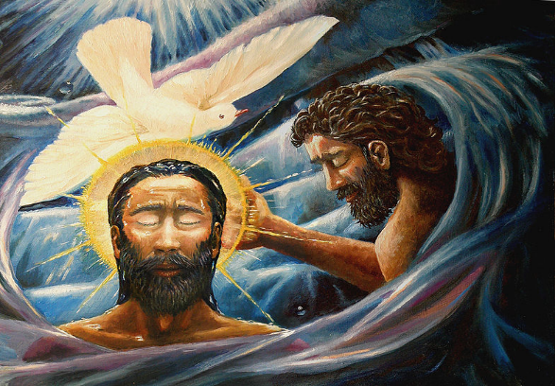Look at the painting. **Do you like the picture?** Give a reason for your answer. **Do you think it portrays the baptism of Jesus accurately?**   
  **The artist is trying to show Trinity. What do we mean by Trinity?  
  How does the artist show Trinity?   
  Can you think of another example from the Gospels where the writer says a voice from heaven was heard?**
* 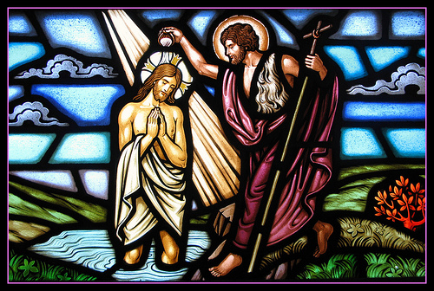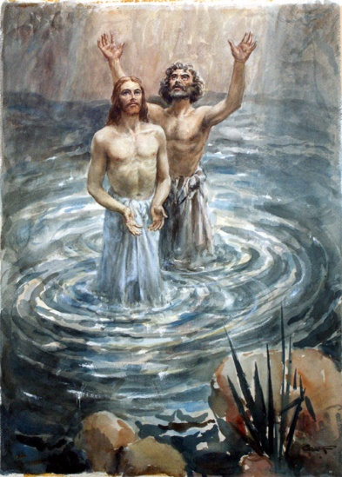In these pictures there is no dove. **How do the artists show something special is taking place?** *(Think about colours, light and gestures).* If you were to draw the scene how would you draw it to show  
   a) Jesus as Son of God and b) Trinity
* **Do you think people around Jesus heard a voice from heaven?** *(Think about this carefully if you heard a voice from heaven what would your reaction be?)*
* Create your own piece of artwork showing the baptism of Jesus, showing what you think is important about the event.

**Geography**

<https://www.bbc.co.uk/bitesize/topics/z849q6f/articles/z7dkhbk> Have a look at this website and then have a go at the quiz.

Could you then design a poster to explain what ‘Climate Change’ actually is?

**Science**

Previously we have found out that yeast grows and produces gas to help us when making bread rise. Now we are going to find out if yeast can also help things decompose faster, by eating the sugar in a piece of fruit.

**APPARATUS:**

There is quite a shortage of yeast at the moment!

If preferred you could continue to **research** foods that use microorganisms!

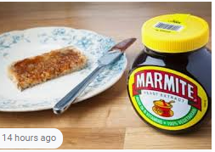

* Banana
* Sealable plastic bags
* Dried yeast
* Sticky labels

**METHOD:**

1. Cut a banana in half lengthways and then in half widthways
2. Put one piece in a bag and seal the bag. Label it ”no yeast”
3. Sprinkle some dried yeast on the other piece of banana, then put it in the other bag and seal it. Label it “with yeast”
4. Put the bags on the window ledge for a few days

<https://www.youtube.com/watch?v=AnQLOBaDHus> The link shows this experiment.

**If you are using any equipment or experiments that use microorganisms, please ask your parents for permission. You should also take extra care when clearing up.**

**PSHE:**

Be Awesome Go Big is a PSHE programme designed for children who are moving from Y6 to Y7. There are copies of the booklet available at the school office or you can print off your own using the link below. Alternatively, you could write down your ideas in a notebook..

Please look at Session 1 – there is a powerpoint to follow, then a couple of tasks in your workbook.

<https://www.hachetteschools.co.uk/landing-page/hachette-schools/be-awesome-go-big-resources-for-year-6/>

Task 1: What is holding you back?

Task 2: What can you learn from your primary experience that you would like to use in secondary? –How did you handle things when they went wrong?

* How did you react when you got stuck?

**Art**

<https://poundarts.org.uk/wp-content/uploads/2020/05/Fold-Your-Town-compressed-FINAL_compressed-1.pdf>

**This year the Pound Arts Festival is online. Could you ‘Fold your own town?’**

**Useful Websites:**

<https://www.nhs.uk/change4life/recipes>- Cooking Ideas

professor assessor <https://prof123.com>

<https://www.bbc.co.uk/bitesize> -lots of ideas and information.