See the source imageOnce upon a time there was a boy. He had a Charizard, a key stone but no mega stone he spent days after days looking for one, he climbed mountains he trekked thorough forests. One day at his house he was playing hide and seek he saw a hole and touched it he got sucked into a jungle he said: ‘I what a Charanite X’ and it dropped from the sky. The jungle was like a volcano he said I hope it doesn't erupt unfortunately it did! Luckily, he used the mega stone and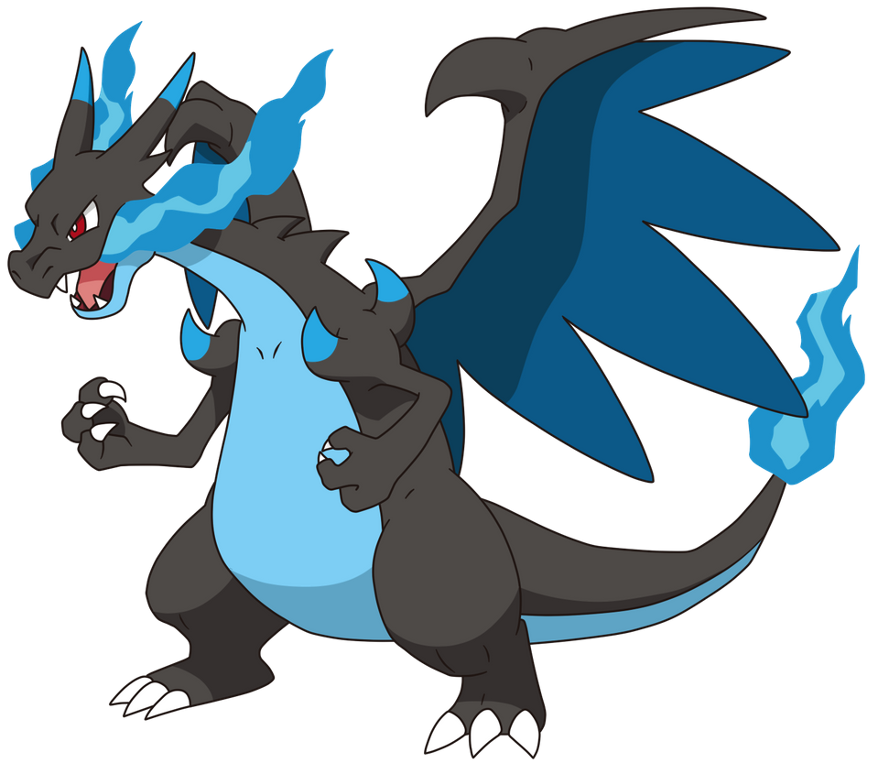 made Charazard mega evolve it used its new ability lava suck to suck up all the lava they went back home and lived happily ever after