Venn diagrams

2x table 5x table

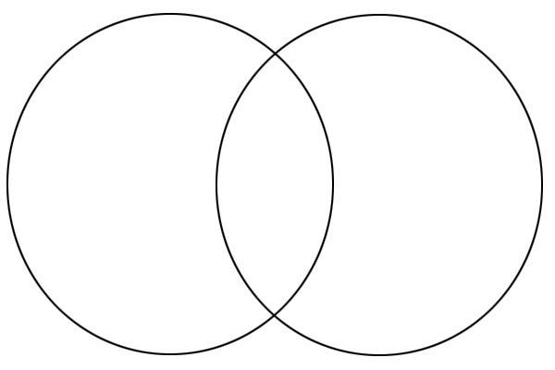

Write the 2x table answers here : Write the 5x table answers here: