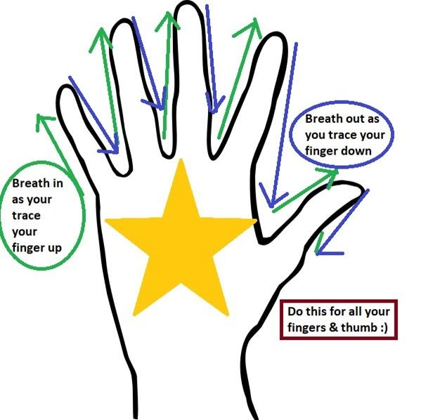

Use this helpful technique to calm down :)

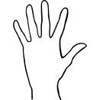
1. Spread your fingers wide on your hand so it looks like a bit like a star
- Use your pointing finger from your other hand to trace those fingers up and down.
- Breath in as you slide your finger up & breath out as your slide your finger down the other side

4.​ Do this breathing until you’ve traced your whole hand :)​
You could even make your own Helpful Hand Breathing poster to help your remember to do this!

