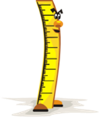Estimate, measure and compare lengths

|  |  |  |  |
| --- | --- | --- | --- |
| Pear_Leaf[1]Object  Eg. | **Estimated**  **length** in cm  (centimetres) | **Actual**  **length** in cm  (centimetres) | **Compare 2 of your measurements and write a sentence about them or use >(greater than),< (less than) and = (equals)** |
|  |  |  |  |
|  |  |  |  |
|  |  |  |  |
|  |  |  |  |
|  |  |  |  |
|  |  |  |  |
|  |  |  |  |