**Home Learning – Lockdown Challenges for Year 2**

**Term 6 Week 7 13th July 2020**

[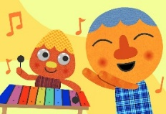](https://www.google.com/url?sa=i&url=https://supersimple.com/song/my-happy-song-featuring-noodle-pals/&psig=AOvVaw0tUmWULuHrGICsX5P6F6y_&ust=1592988053003000&source=images&cd=vfe&ved=0CAIQjRxqFwoTCODjjo_Fl-oCFQAAAAAdAAAAABAE)

1. **Music / Drama / Dance Activity**

Can you make your own beautiful music? Safely collect some glass jars and fill them with different amounts of water. Tap them with a metal spoon to see what sound they make. Is it high or low? You can add more water or pour some away until you like the sounds they make. Make up a pattern, tapping the jars in the same order. Repeat the pattern and then change to a new pattern. Repeat the 2nd pattern and then finish again with you first patter. Can you play the whole tune again? For more idea, watch <https://www.youtube.com/watch?v=iFwtybB3R6Q>

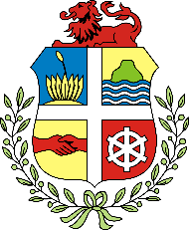

1. **Creative / Craft & Design Activity**

Can you make a coat of arms for yourself or your family? You could design it first and then cut out some cardboard to make the shield and add on your designs. Choose different pictures or symbols that are important or have meaning to you.

1. **Social / Emotional Activity**

Try the ‘helpful hand’ breathing. Show your family the different breaths we did at school eg Rainbow breath, Elevator breath, Bow and arrow breath. Which breath of the day did you enjoy doing? Can you invent some of your own?

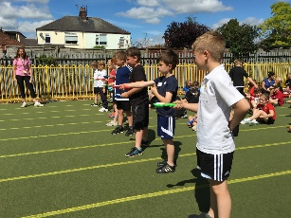

1. **Physical Activity**

Join in with our virtual Sports Day at home! The ‘Rainbow Games’ sports videos are on the Covid 19 News tab on the school website. Watch Mrs Long and then have a go. You can complete your own score sheet and sent it in to be added up for your House team.

You could also try playing the Tokyo Ten: Pirates game.



1. **Spiritual / Reflective activity**

Listen to ‘Here I am Lord’ on Youtube. You could sing along too if you like. Look at the pictures of the different people helping others. What do you think you can do to show God’s love through your actions?

1. 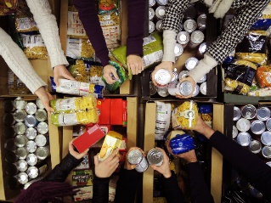**Supporting the Community Activity**

Can you donate a few items to your local foodbank? Foodbanks have put out an appeal asking for donations as they are supporting lots of families during this time. Or you could make a poster to go up in your window instead, appealing for items to be donated. Do you remember visiting our local foodbank last year?

1. [](https://www.google.com/url?sa=i&url=https://www.allmomdoes.com/2017/07/06/reading-is-fun-how-to-make-summer-reading-fun-for-your-kids/&psig=AOvVaw1qB0AVQswovH9ZgK0TL6Ox&ust=1592992160794000&source=images&cd=vfe&ved=0CAIQjRxqFwoTCLD327fUl-oCFQAAAAAdAAAAABAD)**Reading to Relax**

Take part in the Library Summer Reading Challenge. This is the link to the video for the Library Summer Reading Challenge 'The Silly Squad'. (There is also a link on our class page.) <https://www.youtube.com/watch?v=CBLXTwXf4gs>

Which books would you recommend to your friends? Why?

*Remember: There is a new Talk for Writing pack (The Elves and the Shoemaker) and Maths booklets that you can access on the class webpage too if you would like to.*

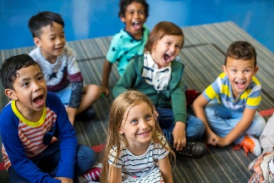 **We are hoping to see lots of you again on Wednesday for your ‘Keeping in Touch’ session (see the newsletter), either 11.00-12.00 or 1.00-2.00pm. You need to email school by FRIDAY 10th JULY if you would like to come: admin@st-patricks.wilts.sch.uk. You will then get a parent mail on Monday 13th July to tell you the time of your session.**

**Please EITHER *Prepare a very short (1 - 2mins) talk / presentation on something that you have learned to do (eg. learned to juggle or knit), practised and improved (eg. drawing, playing an instrument) or conquered a challenge (eg. tidied your bedroom, learned all your tables etc.) You may bring in an example if you wish.* OR *Bring in your coat of arms that you’ve made and explain some of the symbols you chose.***