**Home Learning**

**Year 3 – Term 5 Week 4**

**11th May 2020**

Hello Children and Parents,

I hope you had a good week last week. I was so impressed by your school poems and science work. Well done. It’s great to see children starting their own projects and taking their learning off in different directions. Did you enjoy VE day? Please send any photos in for the class gallery. Last week was National Gardening week and I hope your plants are growing well. Don’t forget to keep them watered and away from slugs and snails. Have you discovered the best place/conditions in your garden for plants to thrive?

I am starting to write your reports so please write me a letter telling me what you have enjoyed in year 3, what you have learned and improved and things you still need help with. You can also tell me any other news you have. I look forward to hearing from you (please send to the school address)

All best wishes,

Miss Wilkinson

**English**

**Lesson 1: Expanded noun phrases**

This is an online lesson - Google BBC Bitesize Expanded noun phrases Daily lessons Year 3 <https://www.bbc.co.uk/bitesize/articles/zhfgcqt>

Watch the video and complete the activities or see below:

A noun phrase is a simple phrase built around a noun.

It contains a determiner and a noun .

For example: a tree , some sweets , the castle

Expanded noun phrase

An expanded noun phrase adds more detail to the noun by adding one or more adjectives .

An adjective is a word that describes a noun.

For example: a huge tree, some colourful sweets, the large, royal castle

Writers use adjectives to make expanded noun phrases because this makes their writing more descriptive and gives the reader a better picture in their head of what the writer is trying to describe.

For example, the expanded noun phrase 'a cute, baby elephant' gives you a much clearer picture than just writing ‘the elephant’ would.

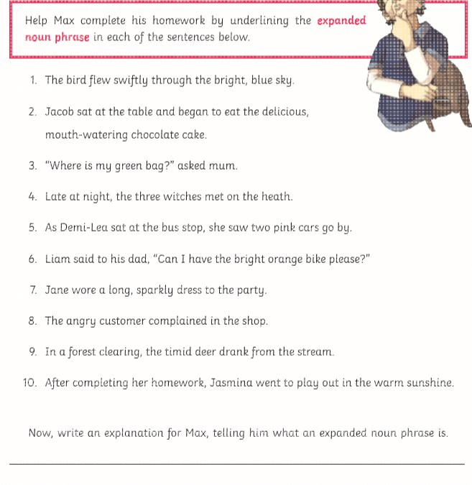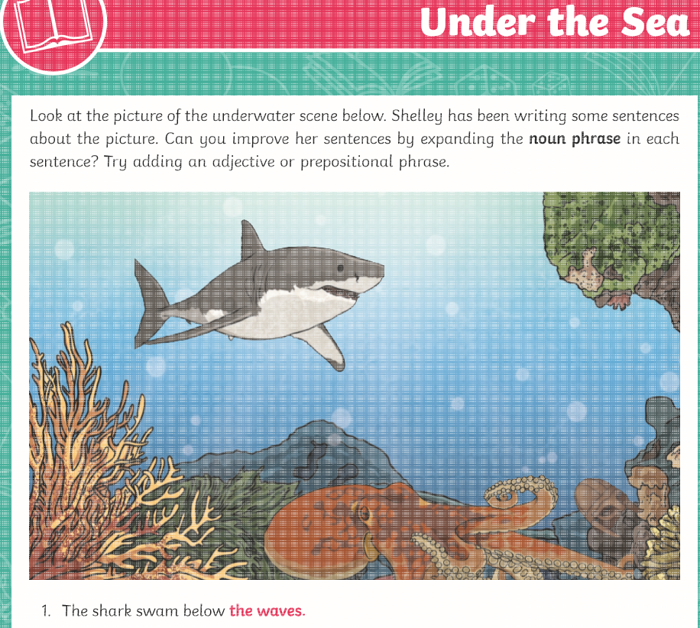

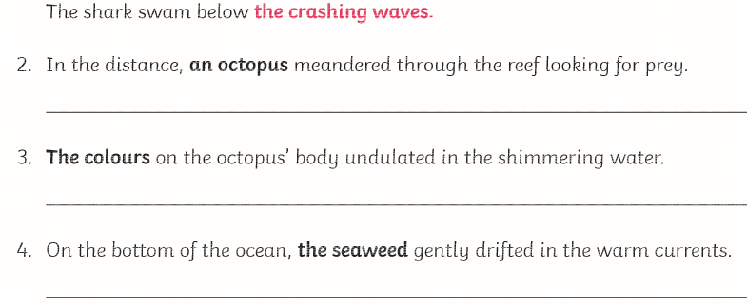 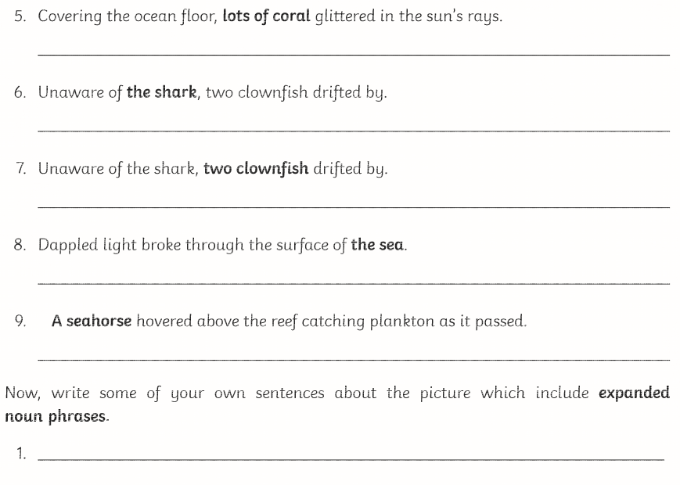

**Lesson 2: Reading and comprehension – Read this extract and answer the questions**

**‘James and the Giant Peach’ by Roald Dahl**

‘Good gracious me!’ Aunt Spiker said,

‘What’s that awful noise?’

Both women swing round to look. The noise, of course, had been caused by the peach crashing through the fence that surrounded it, and now, gathering speed every second, it came rolling across the garden towards the place where Aunt Sponge and Aunt Spiker were standing.

The gaped. They screamed. They started to run. They panicked. They both got in each other’s way. They began pushing and jostling and each one of them was thinking only about saving herself. Aunt Sponge, the fat one, tripped over a box that she’d brought along to keep the money in and fell flat on her face.

1. What did the peach crash through?

2. What was the peach rolling towards?

3. Write 3 things that the Aunts did when they saw the peach rolling.

4. Which Aunt tripped over a box?

5. What had the Aunt brought the box along for?

6. What did Aunt Sponge fall on?

7. What do you think was happening inside the peach at this time?

Take time to have a good reading session and enjoy your book.

**Lesson 3: Spelling**

**Stare-way group**

Google search BBC KS1 English spelling What are Silent letters? Follow this lesson or see below [**https://www.bbc.co.uk/bitesize/topics/zcgv39q/articles/zy4fdxs**](https://www.bbc.co.uk/bitesize/topics/zcgv39q/articles/zy4fdxs)

**Silent letters**

Silent letters are letters that can’t be heard when the word is spoken.

For example in the word ‘sword’, you don’t pronounce the letter ‘w’. And the letter ‘h’ is silent in the word 'ghost'.

There are lots more examples of words with silent letters in English. So keep an eye out for them, because you won’t be able to hear them!

**Highlight the silent letters in these words - K**night castle doubt island write knew know knit thumb

Write out your spellings in best handwriting and then make up simple sentences – don’t forget your capital letters and full stops.

Need more? Revise at BBC Bitesize KS1 Phase 3 Phonics https://www.bbc.co.uk/bitesize/topics/zvq9bdm

**Year 3 Spelling Rule BBC Bitesize KS2 Spelling ough https://www.bbc.co.uk/bitesize/topics/zt62mnb/articles/z9f2b82**

The letters 'ough' can be said in many different ways. Say these words out loud to hear the different sounds.

* plough
* ought
* cough
* rough
* thorough
* thought
* bought
* sought
* tough

Can you think of any more 'ough' words?

**Find the words that rhyme with rough**

**Find words that rhyme with thought**

**Group the words and learn by writing them out several times each. Next write 5 some sentences for these words.**

**Lesson 4 and 5: Expressing feelings through poetry - Write your own poem called ‘In the Lockdown’**

Now you have had this experience, it would be good to create a collection of poems based on your own time. We are living history here! Brainstorm – make quick notes of all the things you have done during the lockdown time so far. Then write down all the feelings you have had. And things that have happened. Then put them into a poem. You can repeat the phrase ‘in the lockdown’ if you wish to give structure. You can choose whether or not to make it rhyme. It’s easier not to rhyme.

Here is mine to help you get started.

Teacher’s Lockdown

In the lockdown, I made a vegetable pie,

In the lockdown, I wondered why?

Why is this happening? Where is my class?

I miss all the children – the teaching, the laughs,

In the lockdown, I queued for my foods,

In the lockdown, I had lots of moods,

A mixture of feelings from anxious to happy

Especially on Thursdays when we went out clapping

For the nurses and doctors, all working so hard

What a way to say thank you! Clapping out in my yard!

In the lockdown, I did P.E with Joe Wicks

In the lockdown, I learned to do high kicks!

I shopped for my neighbour and made a new friend

But some days I really wanted lockdown to end

In the lockdown, I made quiche and stew and curry

In the lockdown, I tried not to hurry

I taught the home learning to a class of 1!

Maths, English - then out in the garden, having fun

In the lockdown, we stayed home to stay safe

In the lockdown, we had to be brave

Helping each other by staying at home

Caring for those especially alone

One day, we’ll look back on this lockdown time

One day, you will read again, Miss Wilkinson’s rhyme

And think back to this strange time in our history

When the secrets of the illness are no longer a mystery.

**EXTRA ENGLISH ACTIVITIES**

Listening to poetry

Listen to poems BBC Bitesize KS2 Poetry Class clips

[**https://www.bbc.co.uk/bitesize/topics/z4mmn39/resources/1**](https://www.bbc.co.uk/bitesize/topics/z4mmn39/resources/1)

Which poem is your favourite? Explain why you like it. How does it make you feel? Is it funny, sad, exciting, thought provoking? Does it make you think? Does it tell a story? Does it make you laugh? Why does it ‘sound good’? What makes it effective? Is it the rhythm, the rhyming, the use of interesting words, repetition, sound words or alliteration?

No computer? Read this poem by Roald Dahl called ‘The Pig’

In England once there lived a big

And wonderfully clever pig.

To everybody it was plain

That Piggy had a massive brain.

He worked out sums inside his head,

There was no book he hadn’t read.

He knew what made an airplane fly,

He knew how engines worked and why.

He knew all this, but in the end

One question drove him round the bend:

He simply couldn’t puzzle out

What LIFE was really all about.

What was the reason for his birth?

Why was he placed upon this earth?

His giant brain went round and round.

Alas, no answer could be found,

Till suddenly one wondrous night

All in a flash he saw the light.

He jumped up like a ballet dancer

And yelled, ‘By gum, I’ve got the answer!

They want my bacon, slice by slice,

To sell at a tremendous price!

They want my tender juicy chops

To put in all the butchers’ shops!

They want my pork to make a roast

And that’s the part’ll cost the most!

They want my sausages in strings!

They even want my chitterlings!

The butcher’s shop!

The carving knife!

That is the reason for my life!’

Such thoughts as these are not designed

To give a pig great peace of mind.

Next morning, in comes Farmer Bland,

A pail of pigswill in his hand,

And Piggy, with a mighty roar,

Bashes the farmer to the floor,

Now comes the rather grizzly bit

So let’s not make too much of it,

Except that you must understand

That Piggy did eat Farmer Bland.

He ate him up from head to toe,

Chewing the pieces nice and slow.

It took an hour to reach the feet,

Because there was so much to eat,

And when he finished,

Pig, of course,

Felt absolutely no remorse.

To put in all the butchers’ shops!

They want my pork to make a roast

And that’s the part’ll cost the most!

They want my sausages in strings!

They even want my chitterlings!

The butcher’s shop!

The carving knife!

That is the reason for my life

Such thoughts as these are not designed

To give a pig great peace of mind.

Next morning, in comes Farmer Bland,

A pail of pigswill in his hand,

And Piggy, with a mighty roar,

Bashes the farmer to the floor…

Now comes the rather grizzly bit

So let’s not make too much of it,

Except that you must understand

That Piggy did eat Farmer Bland.

He ate him up from head to toe,

Chewing the pieces nice and slow.

It took an hour to reach the feet,

Because there was so much to eat,

And when he finished,

Pig, of course,

Felt absolutely no remorse.

Slowly he scratched his brainy head

And, with a little smile, he said,

‘I had a fairly powerful hunch

That he might have me for his lunch.

And so, because I feared the worst,

I thought I’d better eat him first.’

**Maths:**

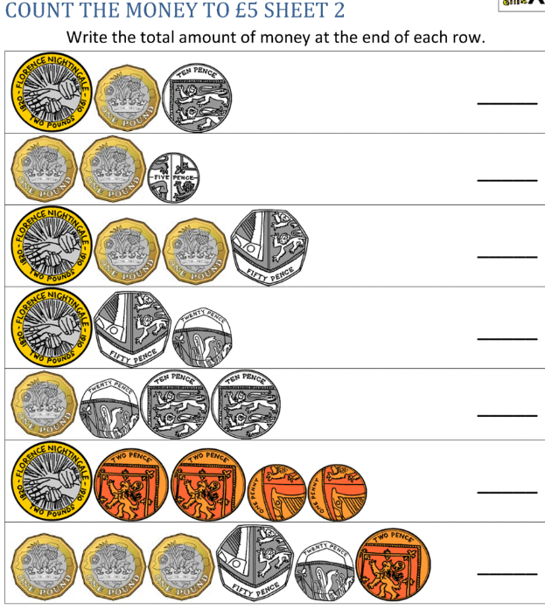

Mental maths: Practise more adding of money at https://www.topmarks.co.uk/money/toy-shop-money

**Maths Topic: Fractions**

We are continuing our unit on fractions for one more week. Adding and subracting fractions and problem solving. We are using the White Rose Maths Hub resources for Year 3 Home learning. These can be found at <https://whiterosemaths.com/homelearning/year-3/> For this week (Week 4), we will be doing ‘*Week 2 Summer Block 5 lessons 1-5*’ (If you are ahead because you started earlier, please find the next sheets on the class website)

Watch the videos and complete the worksheets – you can print them off or read from the screen and write the answers in your book. Hard copies of the maths sheets for the week are available to collect from school.

Next week, we will be starting our unit on adding and subtracting money so time to get the monopoly game out.

**Science:**

**Lesson 4: Food from plants**

Watch my science video the class page. Look at lots of food items in my cupboard and make a chart to say which part of the plant will be eaten? Is it the leaves, root, stem seed or fruit? Some of the items are here in case you can’t watch the video.

Rice Krispies, oranges, grapefruit, bananas, lemons, ginger beer drink, baked beans, tomatoes, kidney beans, plain flour, basmati rice, crisps, sweets, onions, cauliflower, cabbage, broccoli, tomatoes, carrots, peppers, celery….. look in your own cupboard and fridge and identify which part of the plant is being eaten.

Write your own lockdown food diary for the week. How does each food help your body?

Go to BBC Bitesize Science ‘What is a balance diet?’ <https://www.bbc.co.uk/bitesize/topics/zrffr82/articles/zppvv4j> The human body needs a balanced diet to work properly. Good health involves drinking enough water and eating the right amount of foods from the different food groups:

1. **Carbohydrates** give us energy. They are found in foods such as bread, potatoes and pasta.
2. **Proteins** help our bodies to repair themselves. They are found in foods such as fish, meat, nuts, seeds, eggs and cheese.
3. **Fats** help store energy for our bodies. They are found in foods such as butter, cheese and fried foods.
4. **Fibre** is important for helping us digest our foods. It’s found in fruit and vegetables. 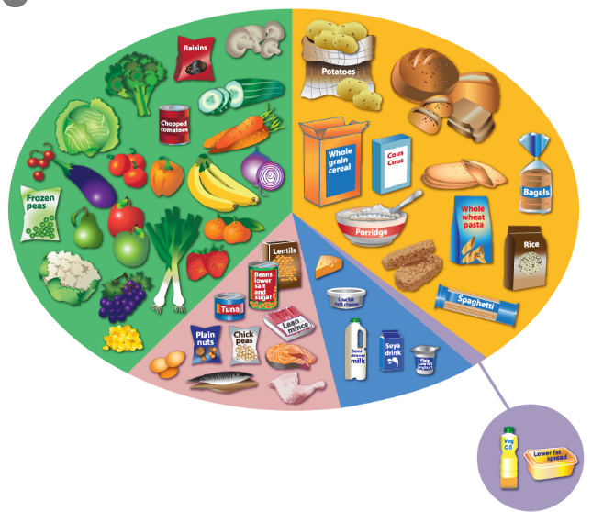

**Geography:** This is also an online lesson - BBC Bitesize KS2 Let's explore the Galápagos Islands.

This is part of Geography People and places

[**https://www.bbc.co.uk/bitesize/topics/z3fycdm/articles/zk9cxyc**](https://www.bbc.co.uk/bitesize/topics/z3fycdm/articles/zk9cxyc)

The Galápagos Islands are home to lots of different types of plants and animals. They contain some of the most unusual animals on the planet. For example, giant tortoises, marine iguanas and even the Galápagos penguin . On his visit to the islands in 1835, Charles Darwin noticed the slight differences between the same types of animal on each island. This helped him work out how they had adapted to their environment through a process called natural selection .

Create your own leaflet or poster for The Galapagos Islands.

**RE/Art: All year groups (Continued from last week)**

1. Take part in the latest competition run by Clifton Diocese. This fortnight, it is another writing task – this time linked to the theme of New Life. This can be as creative as you wish - a Sci-Fi about discovering new life in space, a birth, new life on a farm - anything that connects to the topic. Entries should be less than 750 words and sent to [competition@cliftondiocese.com](mailto:competition@cliftondiocese.com) – Don’t forget to include your name and age. Alternatively, if you wanted to send your entries to the school, we would love to read them ourselves and celebrate them on a class pages. We can also submit them to the Diocese. The deadline is not until **Friday 15th May**, so you have plenty of time to start planning your ideas!

2. Choose a creative way to pray for / send positive messages to the country’s NHS and key workers who are helping to save lives and keep the country going. You could write/draw/paint on pebbles, make prayer flags to hang outside or stick a daily prayer on the fridge and say this each time you open it during the day! If you try any of these ideas, or have come up with your own inventive ways of spreading hope and optimism at home, then help us to share your prayers by sending in photos.

**R.E**

**What is a saint?**

Using the words in the list below, put them in order according to which qualities you think are the most important for a saint to have, and which are the least important. There is no right or wrong answer – as long as you can give reasons for your choices! Use the sentence stems to support you in explaining your choices to an adult.

Create an advert for a saint. This could be in the form of a poster where you draw actions that a saint might do, and include the qualities you thought were the most important from your first activity.

<https://www.catholic.org/saints/fun_facts_arch.php> Fun facts about saints

A saint is somebody who is … because

A saint doesn’t have to be … because

|  |  |  |  |  |  |  |  |
| --- | --- | --- | --- | --- | --- | --- | --- |
| **prayerful** | **poor** | **trustworthy** | **friendly** | **intelligent** | **a man** | **a woman** | **a priest or nun** |
| **young** | **generous** | **willing to change** | **caring** | **keeps on trying** | **old** | **hard working** | **a good listener** |
| **unselfish** | **forgiving** | **listens to God** | **kind** | **goes to church** | **honest** | **courageous** | **rich** |

**Music: Singing**

This is an online lesson on BBC bitesize KS2 Start singing Part of [Daily lessons](https://www.bbc.co.uk/bitesize/dailylessons) [Year 3 and P4 lessons](https://www.bbc.co.uk/bitesize/tags/zmyxxyc/year-3-and-p4-lessons/1) <https://www.bbc.co.uk/bitesize/articles/z7f72sg>

**Activity 1**

**Sing a warm up song of your own choice. Remember the fun songs from school.**

We are going to sing some songs.

But first you need to warm up your voice.

This will help you loosen up, sing your best and make sure you don't hurt any muscles.

**Activity 2**

**Sing along to Somewhere Only We Know or sing a song of your own choice**

Watch and singalong with this choir singing Somewhere Only We Know by Keane.

**Activity 3**

Try out a creative Ten Pieces activity at home. Or listen to classic FM or radio 3 for a change of music.

* Watch films about classical music
* Make art and crafts
* Download sheet music and sing along to famous pieces.

**Times Tables:**

Log in to professor assessor and practise your times tables. Concentrate on learning your 3, 4- and 8-times tables so that you know them by heart. For fun listen to ‘Times Tables Songs 1-12 for Kids | 23 Minute Compilation from Silly

School Songs!’ <https://www.youtube.com/watch?v=C3PojOwjHcc>

**PE/Dance**

**Keep Fit** - Visit *The Body Coach* TV YouTube channel (Joe Wicks) as he is providing a live PE at home lesson.

**Outdoor P.E:** Play any game you have the equipment for. Try setting up a target game using plastic bottles from the recycling. You can have different points for each. Make another circuit indoors or outdoors (check with an adult for safety). Play 7’s catching game against the wall. Chalk out some hop skotch markings to play.

**Dance**: Using animals as your inspiration, create a dance using lots of animal movements.

For inspiration, watch the wonderful Beatrix Potter’s ‘The Tale of Mrs Tiggy Winkle’ The Royal Ballet film https://www.youtube.com/watch?v=TbV4buehg5g