

Wiltshire Cricket Ltd. 2020



Name: __________________________________

Children’s Cricket Activity Book

This small activity book has been developed by Wiltshire Cricket to give children the opportunity to learn, practice and develop their cricket skills alongside some key school curriculums. Wiltshire Cricket hopes that this activity book will engage young children and parents whilst many are in self-isolation. The book contains a wide variety of activities to suit everyone and all can be adapted and changed to provide additional challenge. We hope you enjoy the activity book and we would love to see your children doing some of the activities! Feel free to tag us in videos/photos on social media!

All the best,

Wiltshire Cricket Ltd.

Contents:

1. Make A Mascot
2. Coloured Clothing
3. Cricket Wordsearch
4. Find The Pairs
5. Become an Umpire
6. Become a Scorer
7. Fielding Phonics
8. A Day at the Cricket
9. Congratulations Ben Stokes
10. Sprinting Sums
11. Calculating Catches
12. Active Assault Course
13. Head, Shoulders, Knees, Ball
14. Target Practice
15. Fitness Challenge
16. Edge Challenge
17. Test Match Territories
18. “By the barest of margins…”

# Activity 1: Make a Mascot

Most Cricket teams have a mascot and a logo to represent their team. Usually, the logo and mascot are related to their team name. For example, the mascot for the “Leicestershire Foxes” is a Fox.

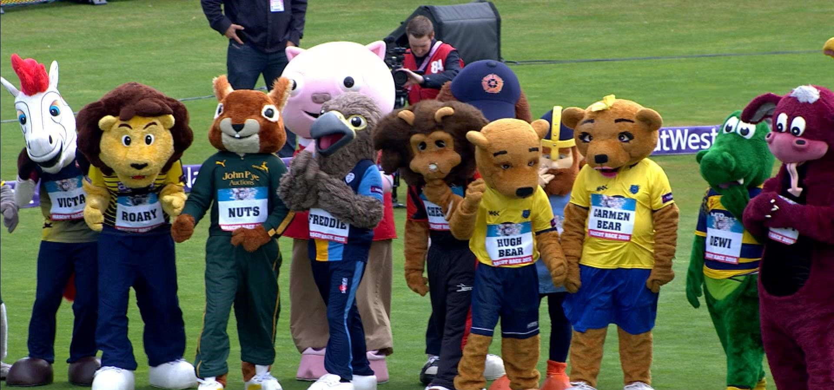

Design your own mascot and Logo for your school /club cricket team:

|  |  |  |
| --- | --- | --- |
| Mascot |  | Logo |

# Activity 2: Colourful Clothing

The HUNDRED, T20 Cricket and One-Day International Cricket are the colourful formats of the game! Using the picture below, can you design your own coloured clothing?

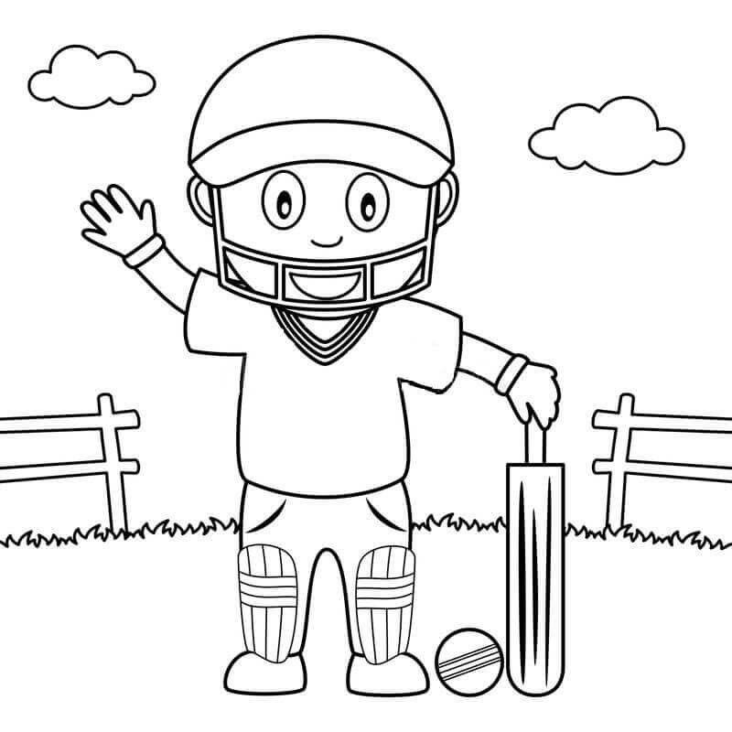

# Activity 3: Cricket Wordsearch

Find all of the cricket related words in the word search below.

Then, on the next page, match up the words with their definition.

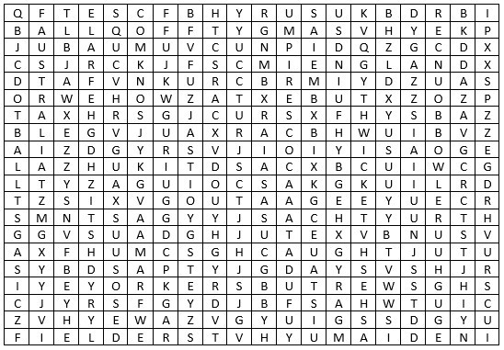

|  |  |  |
| --- | --- | --- |
| Howzat  Caught  Four  England  Australia  Fielder  Bowler | Out  Ashes  Dotball  Umpire  Yorker Ball  Cricket | Maiden  Bouncer  Stumped  Wicket  Six |

# Activity 4: Find the Pairs

Using the definitions below, write down which word you think matches the definition. (Use the Words from the Word Search)

1. A bowler delivers a ball, and it bounces up to the batter’s head.

___________________________________________________

1. The fielding team shout this word if they think the batter is out.

__________________________________________________

1. In cricket, the competition between England and Australia is called the

__________________________________________

1. A batter scores ________ runs when they hit the ball along the floor and it crosses the boundary line.

1. A batter scores ________ runs when they hit the ball in the air and it flies over the boundary line, without bouncing.

1. The person who ensures all of the players are following the rules and playing within the ‘spirit of cricket’. _____________

1. A ________________ is when the batter does not score any runs from that delivery. It is called this because the scorer uses a ‘dot’ symbol in the scorebook.

1. An over is 6 legal deliveries. If a batter does not score any runs in an over, it is called a ________________________________

1. A batter is out, if they leave their crease and the wicket keeper uses the ball to hit the stumps. This method of dismissal is called being

__________________________________________

1. Bonus Question: How many players on one 1 team? ________

# Activity 5: Become an Umpire

In a game of cricket, there are 2 umpires on the pitch. These umpires use signals to communicate with the scorers, the players, the crowd and the other umpire. Can you work out what each symbol means? You may have to watch a game of cricket on the internet to work out why they use some of these signals.



 



# Activity 6: Become a Scorer

Some of the most important people involved with Cricket are the scorers. Their job is to record what is happening and tell everybody who is winning.

Scorers use symbols to record what is happening.

Using the symbols below and watching a cricket match on the internet, can you keep score for 12 balls?

(Pro Tip: If a bowler bowls a wide or a no-ball, they bowl that ball again)

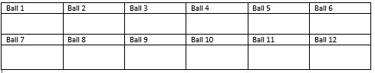

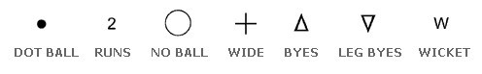

Enjoy Scoring?

Download a scoresheet from the internet and score a T20 online!



Wiltshire Cricket Ltd. 2020

# Activity 7: Fielding Phonics

This is an activity for children and parents.

The children are the batting team! You need to score as many runs as you can by thinking of as many words with the same sounds. For example:

DEEP → BEEP, LEAP, SEAT, EAT, BEAT, SWEEP = 6 RUNS

The parents are the fielding team and their job is to get the batters out! To get a batter out, parents have to check for repeated words, wrong sounds or made-up words. If the batter repeats a word, uses the wrong sound or makes a word up, they lose a wicket!

CHAIR → ___________________________________________________________

___________________________________________________________ = ______ Runs

CHAMPION → ______________________________________________________

___________________________________________________________ = ______ Runs

BUSH → ____________________________________________________________

____________________________________________________________ = ______ Runs

CAR → ______________________________________________________________

______________________________________________________________ = ______ Runs

BOOK → _____________________________________________________________

_____________________________________________________________ = ______ Runs

COW → ______________________________________________________________

______________________________________________________________ = ______ Runs

FORK → ______________________________________________________________

______________________________________________________________ = ______ Runs

FIELDER → ___________________________________________________________

___________________________________________________________ = ______ Runs

# Activity 8: A Day at the Cricket

Summer is nearly here and to prepare for the cricket season, the organisers want to know about your favourite cricket match ever. Could you write a short story describing the day? Think about what you can see, hear and smell as you go to the match, watch the match and perhaps leave after the match.

# _________________________________________ _________________________________________ _________________________________________ _________________________________________ _________________________________________ _________________________________________ _________________________________________ _________________________________________ _________________________________________ _________________________________________ _________________________________________ _________________________________________ _________________________________________ _________________________________________ _________________________________________ _________________________________________ _________________________________________ _________________________________________ _________________________________________ _________________________________________ _________________________________________ _________________________________________ _________________________________________ _________________________________________

## Activity 9: Congratulations Ben Stokes

Ben Stokes had an unforgettable summer of cricket in 2019! His two biggest highlights were the Cricket World Cup Final and the Headingly Test Match.

In the World Cup Final, Ben scored 84 not out and then helped England to Victory in the Super Over, by the barest of margins!

At Headingly, Ben scored 135 not out to win the test match against Australia by 1 wicket!

Can you write a news article about Ben Stokes to go onto your school website You could do some more research on the internet to find some more facts about his team-mates, his opposition, the dates of the matches, the venues etc.

# _________________________________________ _________________________________________ _________________________________________ _________________________________________ _________________________________________ _________________________________________ _________________________________________ _________________________________________ _________________________________________ _________________________________________ _________________________________________ _________________________________________ _________________________________________ _________________________________________ _________________________________________ _________________________________________ _________________________________________ _________________________________________ _________________________________________ _________________________________________

## Activity 10: Sprinting Sums

Cricketers need to be good at running! They also need to be good at Maths. This activity practices both, so that you can be a brilliant batter in the summer!

Run with a cricket bat or ball as a ‘baton’. Collect + or – and 0-9/= symbols and use them to make a ‘sum’ to work out. One number or symbol at a time and remember to ‘slide your bat’.

Use the space below to show your sums.

(Note for Parents: Write down 0-9, + and - on paper for your child to collect as they run to the ’crease’. You could progress this by adding in multiplication, division, bigger numbers or maybe a competition against each other).

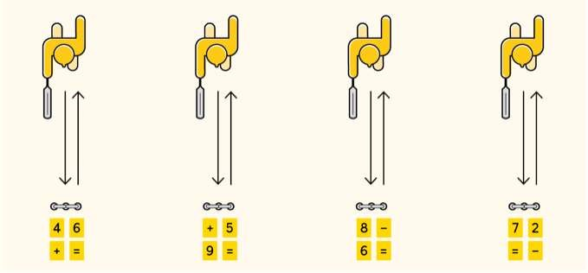

## Activity 11: Calculating Catches

In a pair or a three, stand 2-5 meters away from each other and choose a number 2-10. Throw a ball to one another and count-up in multiples as you catch it.

Too Easy?

1. Subtract a number for every drop-catch. (I.e. 3, 6, 9, 12, 7, 10, 13, 16, 11, 14 etc.) 2. Count Backwards (I.e. 99, 96, 93, 90, 87 etc.)

1. Stand further away from each other.
2. Use one hand.
3. Vary the throws (I.e. Bounce, Roll, High Catch etc.)
4. Use a smaller object. (I.e. Squash Ball) Too Hard?
5. Use a bigger object. A Football? A Cushion? A Teddy?
6. Count-up in smaller multiples.
7. Take more time per catch.

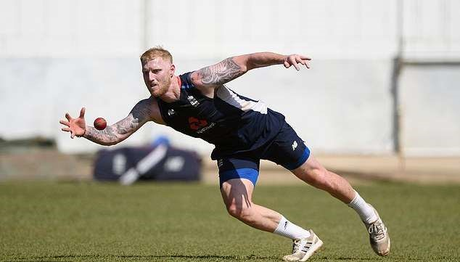

^Photo: Ben Stokes can count to more than 100 using his multiples of 7! How high can you count?

## Activity 12: Active Assault Course

Some Cricket matches are played over a 5-day period. This means that cricketers need to be really fit and agile. Using some items from around your house, create an obstacle course and dribble a ball around the course using your bat.

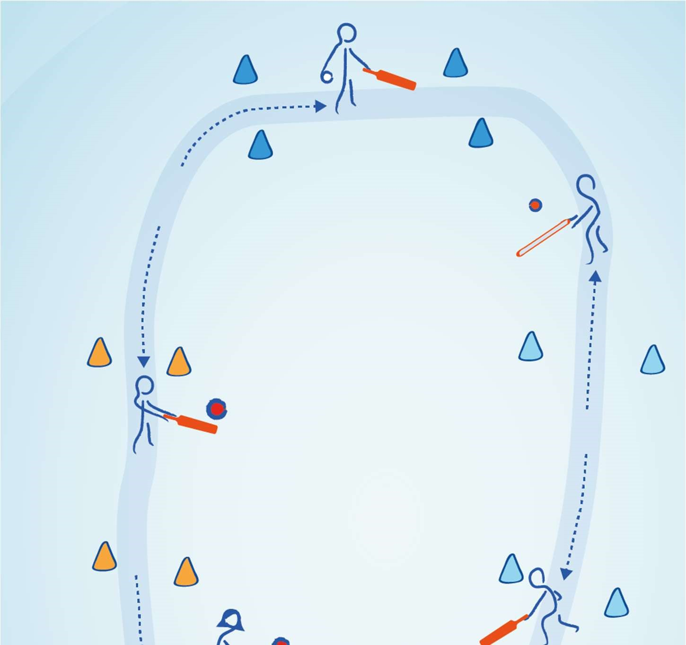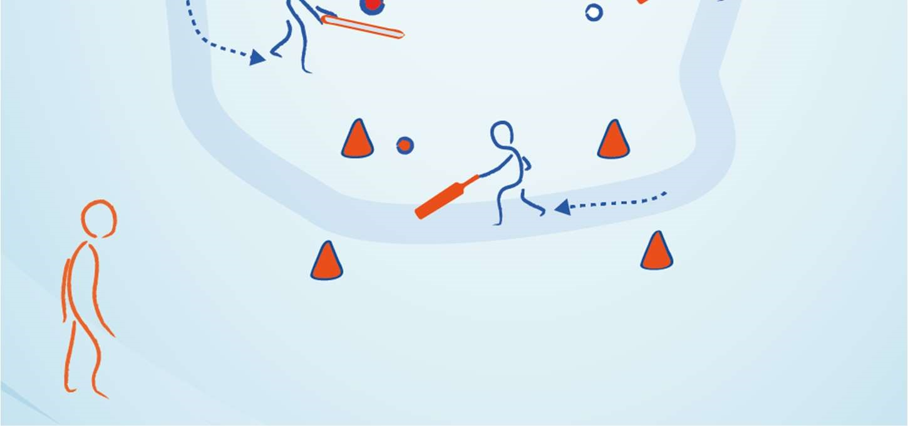

We would LOVE to see some of your assault courses! Why don’t you film yourself doing the assault course and tag us in the videos on social media!

## Activity 13: Head, Shoulders, Knees, Ball

Cricketers also need to practice their reaction times. This activity needs 3 people. Firstly, put a ball on the floor between person 1 and person 2. Person 3 then calls out instructions for Person 1 and 2 (“Head, Shoulders, Feet, Nose, BALL). As the instructions are called, the players should use both hands to touch the correct body part. When ‘BALL’ is called, it is a race to pick the ball up.

Keep a score to see which player is the fastest!

## Activity 14. Target Practice

Throwing is a very important skill in the game of cricket. In this activity, practice your throwing and aiming skills by creating different targets around your house. You could use a ball and a bucket or perhaps some scrunched-up paper and a saucepan.

(Note for parents: This activity could start relatively easy by placing the bucket on the floor in front of you. Progress the activity by asking your child to bounce the paper off a wall, add an obstacle in the way or even create a ‘golf course’ of different targets around the house).



## Activity 15. Fitness Challenge

Are you as fit as Jos Buttler or Tammy Beaumont?

This fitness challenge can be completed everyday whilst you are at home. Using two dice or a ‘Random Number Generator’ (2-12), find out which fitness activities you will be doing today! You should do 5 every day!

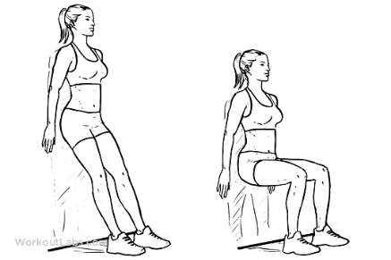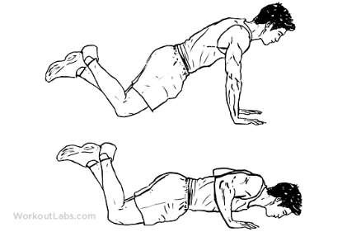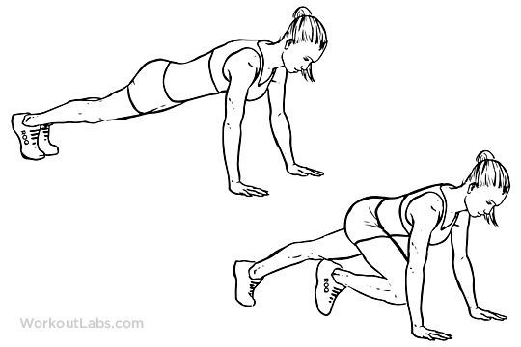

|  |  |  |
| --- | --- | --- |
| 2. 30 Second Wall    Sit | 3. 20 Mountain | 4. 10 Knee Push Ups |

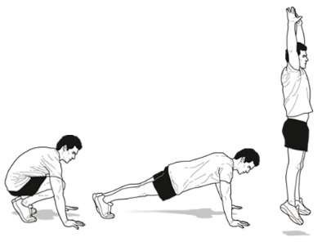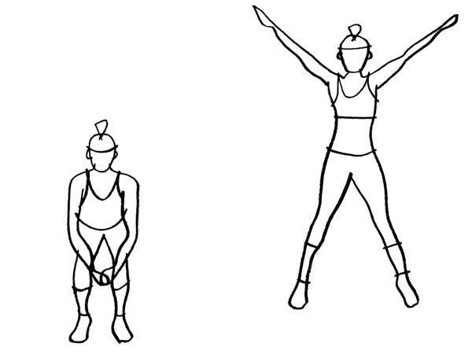

6. 10 Star Jumps 7. 5 Burpees

10

Squats

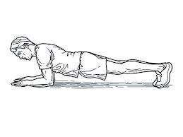

5

. 30 Second

Plank

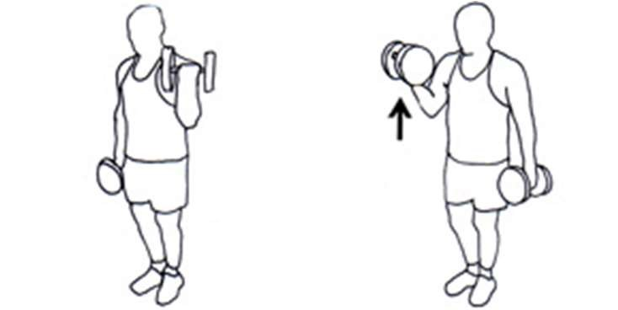

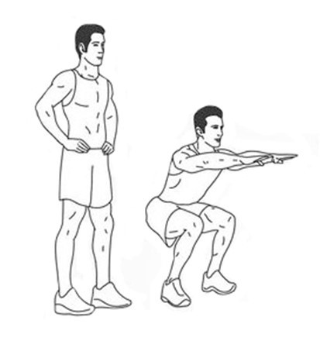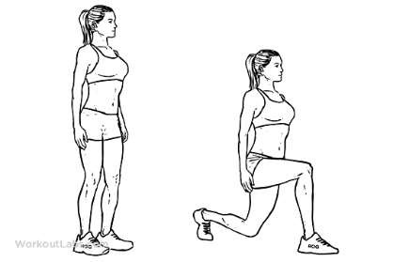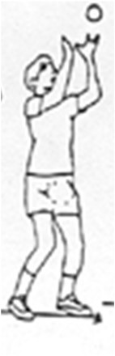

|  |  |  |
| --- | --- | --- |
| 8. 10 Lunges | 9. 20 Catches | 10. 30 seconds of  Wall sitting |

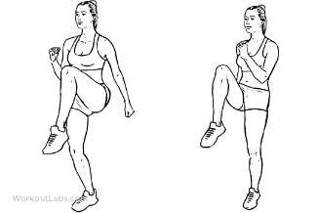

1. 30 seconds of

High Knees

1. 20 Bicep Curls

(Use cans, flour, pasta etc.)

## Activity 16: Edge Challenge

The best cricketers in the world practice every day!

Using a bat and a ball, how many ‘Keep-ups’ can you do? Use the table below to record your best score for each day.

(If it’s too easy on the bat-face, why not use the edge of the bat)

|  |  |  |  |  |  |  |  |  |  |
| --- | --- | --- | --- | --- | --- | --- | --- | --- | --- |
| Day 1 | Day 2 | Day 3 | Day 4 | Day 5 | Day 6 | Day 7 | Day 8 | Day 9 | Day 10 |
|  |  |  |  |  |  |  |  |  |  |
| Day 11 | Day 12 | Day 13 | Day 14 | Day 15 | Day 16 | Day 17 | Day 18 | Day 19 | Day 20 |
|  |  |  |  |  |  |  |  |  |  |
| Day 21 | Day 22 | Day 23 | Day 24 | Day 25 | Day 26 | Day 27 | Day 28 | Day 29 | Day 30 |
|  |  |  |  |  |  |  |  |  |  |
|  |  |  |  |  |  |  |  |  |  |

We’d LOVE to see your attempts at this challenge! Why not film yourself doing the challenge and tag Wiltshire Cricket on social media!

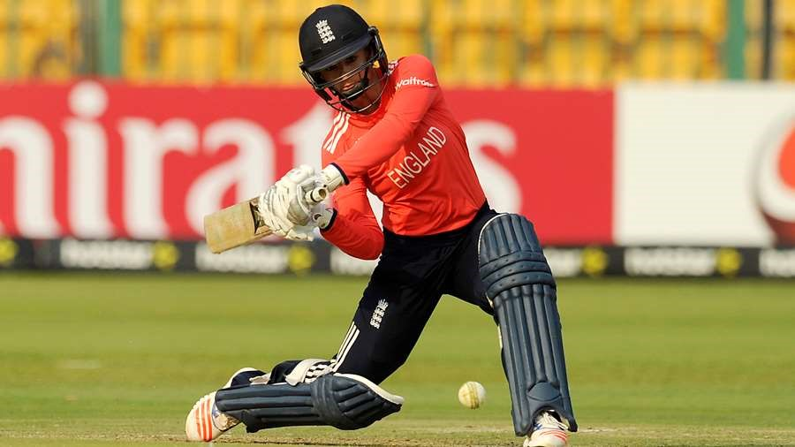

^Photo: Dani Wyatt practices her batting every day! Her top score for the edge challenge is over 100! Can you beat her score?

## Activity 17: Test Match Territories

Cricket is played all over the world, by millions of people! We need your help to find each of the countries on the map below. Draw an arrow from the name of the country to it’s location on the map. You may need to use your computer skills to find out where the country is.



|  |  |  |
| --- | --- | --- |
|  |  |  |
| England  South Africa Australia  New Zealand | India  Sri Lanka  West Indies Pakistan | Bangladesh Afghanistan |

Heather Knight and the England Women’s Cricket Team need to plan their next overseas tour to one of the following countries. Pick a country from the list below and write a short fact file for the team. You may need to use your computer skills to do some research.

* Sri Lanka - West Indies
* New Zealand - Australia

The team will need to know about the following:

* Population of the Country
* Exciting Tourist Attractions
* Duration of the Flight
* Important Cultural Information
* International Cricket Venues
* Opposition Captain Information
* Recent Results for the Opposition

Wiltshire Cricket Ltd. 2020

## Activity 17: Test Match Territories (Continued)

Dear Heather Knight,

To help you with your upcoming tour to _____________________, I have prepared some information for the England Women’s Team. Have a look below…

Wiltshire Cricket Ltd. 2020

## Activity 18: “By the barest of margins…”

The Cricket World Cup Final in 2019 was one of the greatest sporting events of all time and everybody wanted to be a part of it! Well, now is your chance! For this activity, can you recreate the last ball of the match?

Spend some time planning how you can recreate this moment in your house or garden and then film your recreation. You could use the existing commentary from a video on the internet or you could recreate the commentary as well! Be imaginative!

We would LOVE to see your recreations of this incredible sporting event by tagging Wiltshire Cricket in your videos on social media!

Here’s some links to the final scenes. Can you recreate the last ball?

https://www.youtube.com/watch?v=Itb-3pISKt8 https://www.youtube.com/watch?v=-nNJVv48OZM

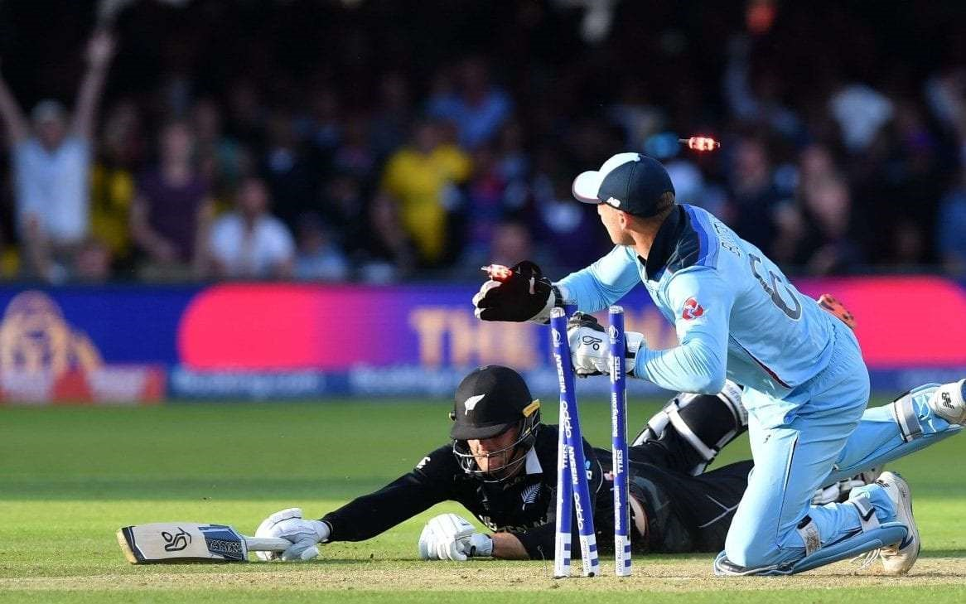

Don’t forget to tag Wiltshire Cricket on Social Media!

We LOVE to see everyone having a go at these activities!

Wiltshire Cricket Ltd. 2020