**English and Maths**

**Year 1 – Term 6 Week 5**

**29th June 2020**

**Maths: (You can choose to do The National Oak Lessons- link on the class page or the lessons below)**

**Geometry and Position:**

* Children should practically turn objects, shapes and themselves in different directions but don’t need to describe the direction of the turns
* Children to use the language ‘Full’, ‘Half’, ‘Quarter’ and ‘Three Quarter’ to describe turns made by shapes/ objects
* Children to investigate whether they can finish facing the same direction if they complete different turns
* <https://www.bbc.co.uk/bitesize/topics/z2grd2p/articles/zwv6b82>

There are some position videos made by the BBC when following the above link.

**Day One:** Get the children used to using the mathematical language of position. Go in the garden and play a Simple Simon says game using the language ‘quarter turn’, ‘half turn’, ‘three quarters turn’ and ‘full turn’. First the follow the instructions given by the adult and then they have a go at using the language and giving the instructions themselves.

**Day Two:**

Find 2 or 3 shapes in your house (not a circle).

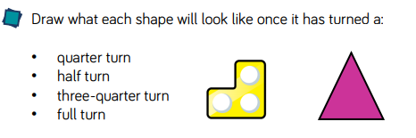

**Day Three**

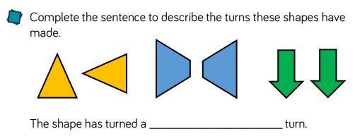

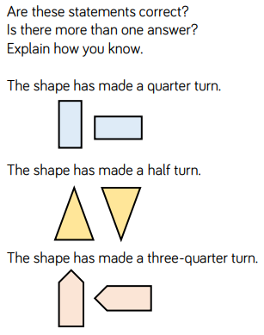

**Day Four**

Children will build upon directional language ‘left’ and ‘right’ to assist with describing position. They will describe position using: ‘top’, ‘in between’, ‘bottom’, ‘above’ and ‘below’. Children explore the position of objects and shapes from different starting points.

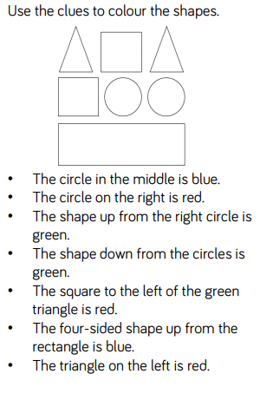

**Day Five**

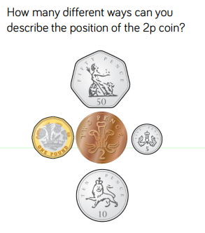

**English:**

**Diary entry**

* Keep up writing your daily journal recording your time and learning at home. Remember to include the events, and your thoughts and feelings. ***Dear Diary…First… Then… After that… I felt… I liked…***

Think about the positive things that have happened in your day. When you reread your diary each day, these memories will help you to focus on the great things that are happening. You can fill it in each day or once a week!

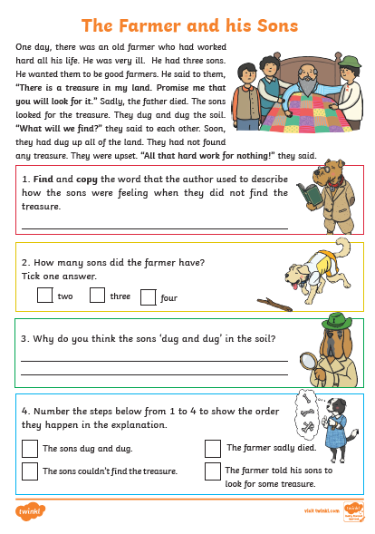**Monday:**

**Tuesday**: What do you think the treasure was? Write a few sentences describing the treasure and draw a picture of it.

**Wednesday**: Imagine that the story was different and the sons found the treasure. Create a story map for your own version, where the sons found the treasure.

**Thursday and Friday:** Use your story plan to write your own version! Can you include full stops and capital letters? What about exclamation marks? Take your time, think carefully about each sentence and use your plan to help!

**OR** In week 9 on the National Oak Academy there is a weeks’ worth of character description writing. You may wish to use these online videos or you can follow the ideas above.

**Phonics:** *Daily phonics lessons are online. Please see the link on our class page.*Don’t forget the flash cards are there to watch on our class page!