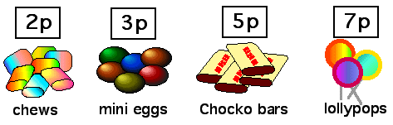

How much are:-

1. 7 chews 7x2= 2. 3 choco bars 3x5p=

3 4 mini eggs 4x3p = 4. 9 chews 9x2p=

5. 5 choco bars 5x5p= 6. 6 mini eggs 6x3p=

7. 5 lollypops 5 x7p= 8. 10 chews 10x2p=

9. 10 mini eggs 10x 3p= 10. 10 choco bars 10x 5p=

Now make up 4 sums of your own. Write out the sums in the same way.

1.

2.

3.

4.

If I have 30p, how many mini eggs can I buy?

If I have 30p, how many choco bars can I buy?

If I have 30p, how many chews can I buy?