Estimate, Measure
and Compare

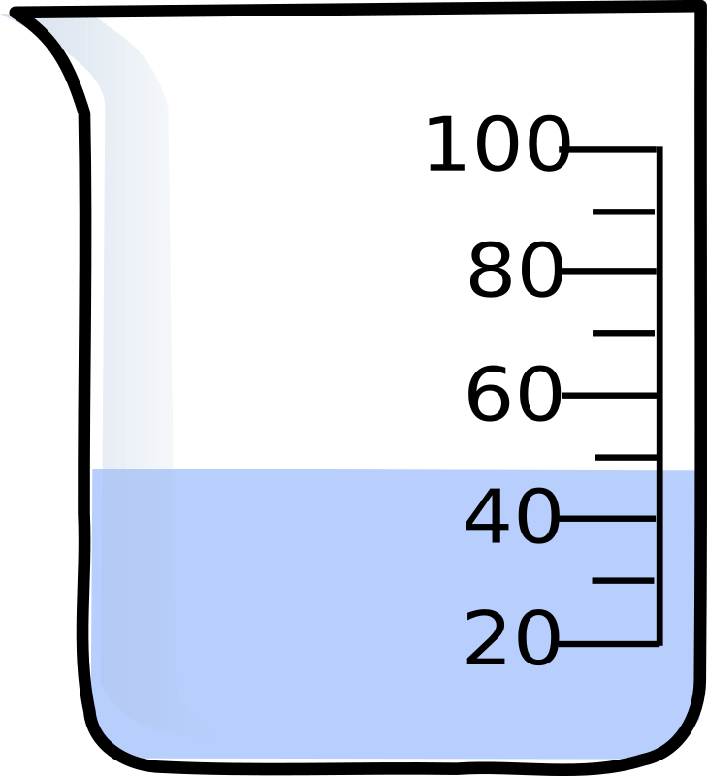

container | Estimated  capacity | Actual  capacity

