**Home Learning**

**Year 2 – Term 5 Week 3-Week beginning 4th May 2020**

**Reading:**

Try and read a few pages every day.

Over the week:

* Look at the front cover of a book and make a prediction on what you think the book will be about. Think about where the story might be set, the characters you think may be involved in the story and what you think will happen. Use the following sentence stems: **I wonder if…., I think that…, I imagine……, I predict… because…**
* As you are reading your book, ask the person you are reading to to ask you some questions about the book (using sentences beginning with **who, what, when, where, why & how).**
* Once you have read your story, tell an adult about what you have read.

Think about the key points or events that happened within your story and include these in your summary.

* Have a go at the reading comprehension linked with the Great Kapok Tree.

**English:** The Great Kapok Tree by Lynne Cherry

*WALT: Retell a story*. Watch **The Great Kapok Tree** story (youtube).What was it about? Where is it set? What did you think of the book? Using the video of the retelling of the story (pause it as you need to), do a picture map of part of the story. Add actions. Retell you section.

*WALT: Identify excellent word choices*. What did you notice about the language/vocabulary in the book? Look at the text (see ‘text’ document) and pick out great vocabulary. Underline or write a list of your favourite words and phrases.

*WALT: write in sentences.* Write some sentences about the Great Kapok Tree story. You can use some of your favourite words and phrases from yesterday. Remember to use capital letters and full stops correctly. Try and include some extended (longer) sentences using because/so/ when.

*WALT: write descriptive sentences.* What do we need to do to write great descriptive sentences? Think about using our senses. Use adjectives. Look at the pictures from the book. Write sentences based on The Great Kapok Tree, using descriptive language. Use your sounds to help with your spellings. Remember to spell your common words correctly. You can use words from the book to help you too. (*You could watch and do the online lesson from the National Oak Academy- online classroom- subject-Year2-English-Lesson 4: to identify and use expanded noun phrases.)*

*WALT: Practise spellings and handwriting*. Choose some spellings from this week’s writing to practise. Practise your handwriting by copying out a section that you like from the book (use the ‘text’ sheet). Remember to try and join your letters and to form them correctly.

Phonics/ Spellings- How did you get on with your spelling test last week? Are there any words you need to go back to to practise? This week we are looking at words that make the –le sound ending, but they are spelt a different way which is more unusual ( -il words). We are also practising some common word spellings. Learn the spellings in your group list. Have your test at home at the end of the week after you have practised your spellings a few times.

Group Three

1. my
2. go
3. went
4. the
5. old
6. cold
7. told
8. gold
9. fold
10. hold

Group Two

1. pupil
2. pencil
3. back
4. path
5. golden
6. last
7. past
8. class
9. great
10. after

Group One

1. fossil
2. stencil
3. pencil
4. pupil
5. council
6. great
7. wonderful
8. friendly
9. amazement
10. beautiful

**Maths-**

* **Go to** [**www.whiterosemaths.com/homelearning/**](http://www.whiterosemaths.com/homelearning/) **More Addition and Subtraction work**

**Click on Year 2, week 3. Watch the video, try the questions-watch out, the more you do, the harder they get!**

* Practising Measuring-length, capacity and weight

**Monda**y: Find different objects and estimate how long they are (don’t cheat!). Then measure them accurately. You should find that you get better at estimating length. Complete the estimate, measure and compare worksheet for length.

**Tuesday**: Find 5 different containers. Working with an adult to help with measuring accurately, how much liquid do they hold? This is measuring the **capacity** of each container. Look around the kitchen at different containers of liquid. How much does the label say they hold? Make a list of the different containers, Check the freezer too because ice cream starts off as a liquid!

**Wednesday**: Complete the estimate, measure and compare worksheet for capacity.

**Thursday:** Practise weighing different things (I’m hoping that you have some kitchen scales-fingers crossed!) and reading the measurements. Test out your skills by making a cake! Why not send me a photo?

**Friday:** Complete the estimate, measure and compare worksheet for weight.

* 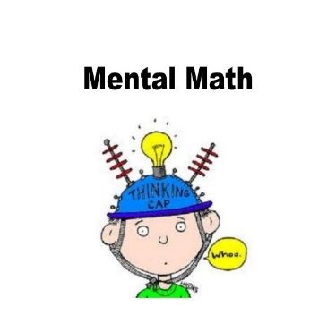**Mental Maths**

Superfast subtraction questions within 20 and then try subtracting from numbers up to 30

Tell the time –Look at the time when it is 5 to, 10 to, 20 to and 25 **to** the hour

Which sum has the lowest answer?

12 + 14 36-13 48 -26 9 + 18

**Don’t forget you can log in to Professor Assessor and we will be able to see your results!** [**https://www.prof123.co.uk/**](https://www.prof123.co.uk/)

**Science: Plants:** On your daily walk, look out for different plants that you can see. Can you identify and name any of them? You could take some photos or draw some of the different plants you can see. Look at BBC Bitesize – KS1 -Science – Plants. The woodland trust website has some identification charts too. If you have the facility at home, try planting some plants too.

At school, we have planted some runner beans in soil and some without soil. We’re finding out if seeds need soil to grow. What do you think? If you can, plant some seeds in soil and some without (you could keep them on damp kitchen roll on a tray or in a jar.) Wait and see what happens!

**History:** It is VE Day on Friday 8th May. What can you find out about VE day? Can you make some bunting to go up in your house to celebrate it? You can look it up on bbc.co.uk, Great British Bunting.

**Geography-** Find out about the Amazon Rainforest. Where is it? What continent is it on? What ocean do you cross to get there from England? You can watch Youtube clips about the Amazon to find out some more.

**PSHE/Acts of kindness** Draw a thankyou picture and write a message for someone of your choice. It could be someone in your family or it could be one of the key workers like your postman or dustman. You could put it up in your window.

**RE: Paschal Candle**

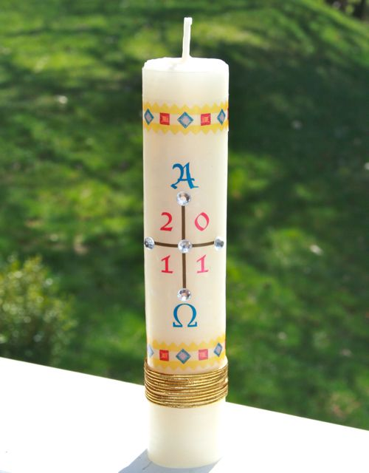In the picture, you can see a Paschal Candle. The word Paschal means Easter so a new Paschal candle is lit each Easter. This is an old Easter Candle used a few years ago.

Look carefully. What can you see? Can you find out what each symbol on the candle means? Use the words from Easter Vigil Service below to help you.

What do you think might be different about this year’s Easter Candle?

Draw and label a Paschal Candle for this year and label it with the symbols included and their meaning.

Christ yesterday and today *(vertical arm of the cross)*   
the Beginning and the End *(horizontal arm of the cross)*   
the Alpha *(alpha above the cross)*   
and the Omega *(omega below the cross)*   
All time belongs to him *(During these 4 lines the priest puts the date)*

and all the ages

To him be glory and power

through every age and for ever. Amen

*Then the priest may insert five grains of incense into the candle in the form of a cross, meanwhile saying:*  
1. By his holy  
2. and glorious wounds,  
3. may Christ the Lord  
4. guard us  
5. and protect us. Amen.

The priest lights the candle from the new fire, saying:

May the light of Christ, rising in glory,   
dispel the darkness of our hearts and minds.

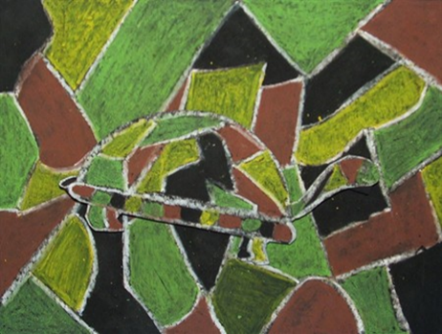**Art** : Find quite a large picture of a Rainforest animal (or draw your own) Now can you camouflage the animal using leaves, plants and grasses or shapes that are a similar colour so that it is hard to spot your animal? This example of a turtle uses pastels, but you could use crayons, felt pens or paint.

Don’t forget you can send a photo or scan of your picture that will get to us via [Sarah.Taylor@st-patricks.wilts.sch.uk](mailto:Sarah.Taylor@st-patricks.wilts.sch.uk)

**PE**

Visit *The Body Coach* TV YouTube channel each morning at 9am as he will be providing a live PE at home lesson. <https://www.youtube.com/channel/UCAxW1XT0iEJo0TYlRfn6rYQ>

Go for a cycle ride or out on your scooter as part of your daily exercise. Try some different skipping games.

**Music:** Learn the Rainforest song about the different layers in the rainforest-the tune is the same as ‘If you’re happy and you know it, clap your hands’!

**Useful Websites:**

<https://www.topmarks.co.uk/>- Maths and English interactive activities

<https://www.nhs.uk/change4life/recipes>- Cooking Ideas

<https://www.bbc.co.uk/bitesize/dailylessons>- Daily lessons for each year group. The maths fits in with White Rose Maths too