**Home Learning**

**Year 2 – Term 5 Week 5-Week beginning 18th May 2020**

**Reading:**

Try and read a few pages every day.

Over the week:

* Look at the front cover of a book and make a prediction on what you think the book will be about. Think about where the story might be set, the characters you think may be involved in the story and what you think will happen. Use the following sentence stems: **I wonder if…., I think that…, I imagine……, I predict… because…**
* As you are reading your book, ask the person you are reading to to ask you some questions about the book (using sentences beginning with **who, what, when, where, why & how).**
* Once you have read your story, tell an adult about what you have read.

Think about the key points or events that happened within your story and include these in your summary.

Reading comprehension: choose the level you want to do. Read and answer the questions in the ‘rainforest’ comprehension. This will also give you information you can use in your English writing.

**English:** The Great Kapok Tree by Lynne Cherry

***WALT: write different kinds of sentences****.* Sentences with different forms: statement, question, exclamation, command . Write sentences, linked to The Great Kapok Tree. Try to write all different types. Use the correct punctuation. (You can look at BBC bitesize, KS1, English, Grammar: How to write… commands/questions/ exclamations/statements to help you.)

***WALT: write some extended sentences****.* *Use of subordination (using when, if, that, or because) and co-ordination (using or, and, or but)*. Write sentences, linked to the book. Eg what do you like about it? Why? What events happened? What reasons did some of the animals give to persuade the man? Remember to use a variety of joining words. Challenge: use speech marks. (You can look at BBC bitesize daily lesson for 12th May – using conjunctions to help you).

***WALT: write descriptive sentences*** What do we need to do to write descriptive sentences? Think about using our senses. Remember to use adjectives. Write sentences to describe a rainforest. You can base it on pictures from The Great Kapok tree or from other pictures of the Amazon rainforest that you find. (If you want to learn more about writing setting descriptions you can go on the national academy website and look at Y2, English, Genre: setting descriptions Lessons 3-5).

***WALT: present non-fiction writing*.** Look at the rainforest information powerpoints. You can also look up information on the computer or use information from the reading comprehension. Pictures and captions – practise this way of presenting non-fiction work. Headings/using a question as a heading. Remember to use commas in a list. Write information sentences about rainforests. Challenge: add an ‘interesting fact’ box. Remember to use interesting vocabulary. Are there specific topic words you can include?

***WALT: Edit and improve work***

Re-read work from yesterday. Check it, edit it, make additions and improvements. Add illustrations. Send us a photo of your completed rainforest information work.

Phonics/ Spellings- How did you get on with your spelling test last week? Are there any words you need to go back to to practise? This week we are looking at 2 words that join together to make a new word. These are called ***compound words***. (Have a look at BBC Bitesize, KS1, English, Spelling).Have another practise of certain homophones too– their/they’re/ there and to/too/two (Have a look at BBC Bitesize, KS1, English, Spelling). Please keep practising some common word spellings as well. Learn the spellings in your group list. Practise using them in a sentence, remembering to use capital letters and full stops. Have your test at home at the end of the week after you have practised your spellings a few times.

Group One

1. rainforest
2. starfish
3. greenhouse
4. footprints
5. sunshine
6. moonlight
7. somewhere
8. anybody
9. whatever
10. underground

Group Two

1. rain
2. forest
3. rainforest
4. green
5. house
6. greenhouse
7. foot
8. ball
9. football
10. sunshine

Group Three

1. all
2. ball
3. fall
4. call
5. called
6. far
7. star
8. fish
9. starfish
10. football

**Maths-**

* **Go to** [**www.whiterosemaths.com/homelearning/**](http://www.whiterosemaths.com/homelearning/) **Multiplication and division**

Don’t forget, we have paid for the premium worksheets for Year 2 and they are on the class page.  **There is no need for you to pay White Rose for any resources. Click on Year 2, week 5 .** Watch the video, try the questions-watch out, the more you do, the harder they get!

* **Practise - sorting data.** This week we’re sorting different things into groups and working out what to do if information can be sorted in more than one way. We use venn diagrams if some of the information overlaps eg carrots are **food**, but they are also **plants**. So we use overlapping circles and put carrots in the middle section because they are in both the food and the plant circles. We use a different system if we sort information in 2 ways eg children who might be able to swim but can’t ride a bike.

DON’T PANIC ABOUT THIS NEW LEARNING!! You can look at venn diagrams for KS1 on BBC Bitesize and then have a look at the worksheets. Lewis Carroll, of Alice in Wonderland fame, also invented Carroll Diagrams. The best way to learn about them is by sorting the information that you are given on the worksheets. There should be plenty of discussion and conversation!

* **Monday**  Venn Diagrams-sorting plants and food
* **Tuesday** Venn Diagrams-sorting animals and things that fly
* **Wednesday** Venn Diagrams- sorting 2x and 5x tables AND 2x and 3x tables
* **Thursday** Carroll Diagrams-answer questions
* **Friday** Carroll Diagrams-sorting data

**Don’t forget you can log in to Professor Assessor and we will be able to see your results!** [**https://www.prof123.co.uk/**](https://www.prof123.co.uk/)

If you would like to know your login details again, do let us know.

**Science: Plants:** Lots of exotic fruit grows in the rainforest, from bananas, oranges, pineapple, papaya, tangerines, coconut and mangoes to lemons. The rainforest also gives us avocadoes, figs, dates, limes, grapefruit and passion fruit, among many others. Try growing your own rainforest by planting any pips or seeds from these fruits (or apples and pears) in some compost and watching to see which ones germinate. Where are the seeds in bananas?!

**History:** Florence Nightingale was born 200 years ago on Tuesday, May 12th. Amazingly she was the first to show how important nurses are, how infections can be slowed down by keeping patients apart and by making sure everyone washed their hands-things that are just as important for us today! In 2020, the new hospitals are named after her. Hopefully, you found some interesting information about her last week.

Now, write a letter to her, telling her about what is going on today and how we’re still following her nursing advice today. This will become one of the history lessons of the future!

**Geography-** Can you find out how Fairtrade bananas or cocoa get from the rainforest to our supermarkets? You will find lots of information on the Fairtrade Foundation website. Investigate where bananas and/or cocoa grow. Find a map of the world and work out a route to the UK if they came by boat or by aeroplane.

**RE:** Last week, you explored what prayer is and the different reasons why people pray and places where people might pray.

[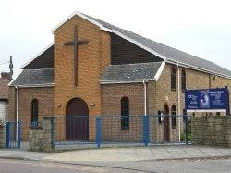](https://www.google.com/url?sa=i&url=https://www.facebook.com/OLOLParishKingswood&psig=AOvVaw0MEiP38x9DvigFLXV4iVbs&ust=1589530352451000&source=images&cd=vfe&ved=0CAIQjRxqFwoTCMDNr5X0sukCFQAAAAAdAAAAABAD)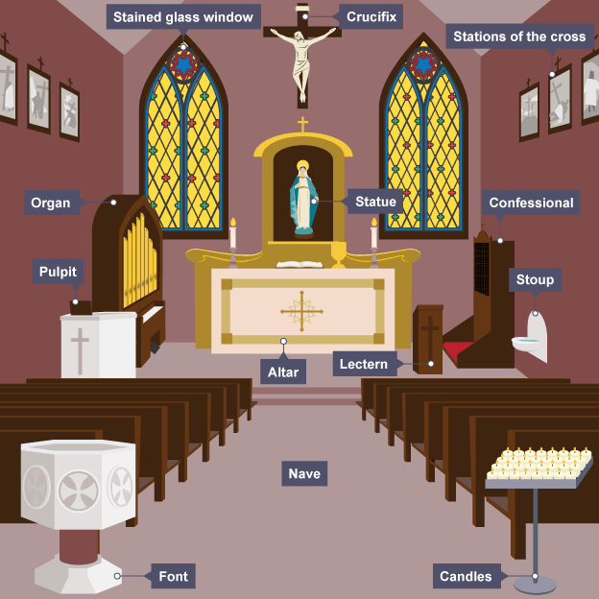Many Christians gather in **church** to pray. Can you design your own church? What should be included? Think about what you usually find in a church. There are some pictures below to support you. You can draw your church, make it out of Lego or choose your own creative way of showing your ideas

Our Lady of Lourdes, Kingswood

[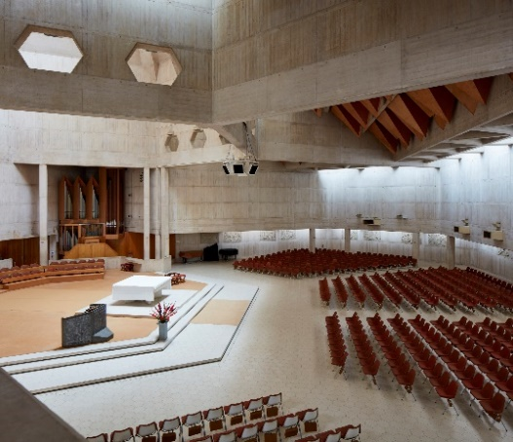](https://www.google.com/url?sa=i&url=https://www.archdaily.com/898613/clifton-cathedral-purcell&psig=AOvVaw09jnoYUh2UJXNhQ9UMxbIh&ust=1589530403148000&source=images&cd=vfe&ved=0CAIQjRxqFwoTCPiQxMH0sukCFQAAAAAdAAAAABAD)

Clifton Cathedral

**Art :**

**Art-Make a ‘habitat in a box’**

Rainforests are habitats for certain animals and plants-they like the weather in that part of the world and also the type of ground there. Penguins could not live there but the Kapok tree could not survive in another habitat such as a desert. Find a shoe box or something similar. When you’ve decided which habitat you’d like to do (eg Rainforest, Ocean, Desert, Forest, Polar) paint or line the inside of your box with paper which is the same colour as the background to your habitat. Fill the box with plants, rocks etc-anything found in your habitat or drawings or models. Add any of your own animals or find some to cut out at <https://www.firstpalette.com/printable> and send us a photo!

**PSHE/Acts of kindness** The Red Cross have been suggesting all sorts of ideas for lockdown and now have issued some First Aid activities for Primary age children which you might like to challenge yourselves with. Here is the link:

**https://firstaidchampions.redcross.org.uk/primary/**

**PE**

Visit *The Body Coach* TV YouTube channel each morning at 9am as he will be providing a live PE at home lesson. <https://www.youtube.com/channel/UCAxW1XT0iEJo0TYlRfn6rYQ>

We can play golf now so can you make a golf game for your living room or garden? The aim is to be able to send a ball in a straight line to a target of some sort. If you’ve ever played Crazy Golf, you might have some good ideas or look at <https://www.golf-foundation.org/clubs/junior-golf-passport/your-passport-to-golf-at-home>

**Useful Websites:**

<https://www.topmarks.co.uk/>- Maths and English interactive activities

<https://www.nhs.uk/change4life/recipes>- Cooking Ideas

<https://www.bbc.co.uk/bitesize/dailylessons>- Daily lessons for each year group. The maths fits in with White Rose Maths too <https://www.thenational.academy/>3 hours of online lessons daily.