**Home Learning-Answers**

**Year 1 – Term 6 Week 3**

**15th June 2020**

**Maths**

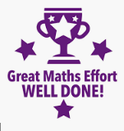

If you require any answers to any of the Maths Home Learning please don’t hesitate to email or call us at the school. We are happy to talk you through any concepts or answers anytime.

**Reading:**



**English:**

We hope you enjoyed writing your recounts and your diaries. How many of the time connectives did you manage to use? We would love to see some of the work you have been doing, send us an email and brighten our day!

**Science:**

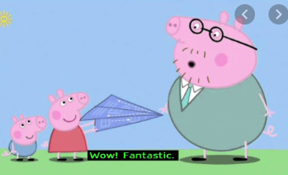 **We hope you enjoyed this special experiment!**

**History:**

It has been wonderful to see all your history work and hear about how much you are enjoying it ☺

**Geography:**

We hope you didn’t get lost! Fantastic map work everyone ☺

**Art- Father’s Day Cards**

What fantastic Father’s Day Cards!



**RE:**

**Remember telling the truth is so important! Well done everyone.**

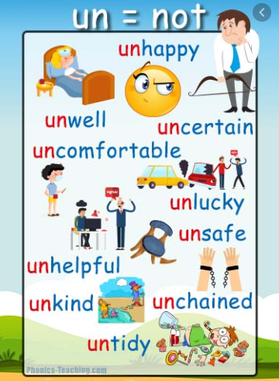**Grammar and Punctuation:**

Here are some more examples! Well done all ☺

**PE**

**Here are lots of activities to work on at home for Term Six**

https://www.sportengland.org/jointhemovement#get_active_at_home

**PHSE-** We would love to know how your circle time went!

 Well done everyone – talking is great for your mind!