Book Choice – independent reading…. 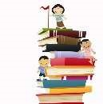

Lots of books can be shared, talked through or done as paired reading. The following ideas are to support children reading on their own.

  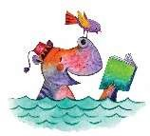

As a rough guide you should be aiming for 90-95% accuracy for independent reading. This allows for some ‘challenge’ – working out words – without losing the meaning of the text.

An easy way to do this is for the child to use the five-finger rule…

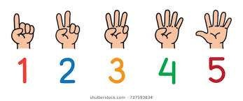

* Choose a random page from the book and start reading
* Hold up a finger for each word they don’t know as they go through the page
* Use the following to help decide

0 or 1 – likely to be too easy

1. – will provide some challenge with a chance to learn a few words
2. – will possibly need a bit of help but not too much
3. or 5 – likely to be too difficult to read on their own, so either do as a shared read or try a different book

As well as accuracy, understanding the text is important.



Conversations about the book could be done alongside visual prompts to support key question vocabulary

 -

These are ideas from Colourful Semantics, but you could make your own.

Specialist SEN Service (SSENS) Wiltshire Council