**Home Learning**

**Year 3 – Week 7**

**8th June 2020**

Hello Children and Parents,

I hope you have had a good first week back after the holiday.

As last week, you can use this pack as it stands or you can use the Oak Academy and BBC bitesize daily on line if you wish [https://www.thenational.academy/online-classroom/year3#schedule](https://www.thenational.academy/online-classroom/year-3#schedule)

Please follow the Year 3 schedule for English and the Foundation subject.

We will no longer be following the White Rose maths as they seem to be repeating some content on fractions. We will be starting a unit on telling the time now.

FUN ACTIVE LEARNING PROJECTS:

Here are 3 fantastic projects which can form the basis for your science, art and history for several weeks.

What have you achieved this lockdown? PHSEE activity

Please send in any photos/videos or written information in answer to the question, what have you achieved during lockdown? It may be lots of plants growing in your garden or perhaps you have learned a musical instrument or a language. Maybe you have learned to cook or bake or use the washing machine!

Please send in any ideas so we can start to put these together and share with those children in school.

‘The Living Lockdown Project’ History Project

The Wiltshire and Swindon History Centre in Chippenham has started the ‘Living Lockdown Project’ and is collating an archive showing how our lives have been transformed by the crisis. You can contribute your diaries, stories, poems or photographs. Please visit the website [www.wshc.eu](http://www.wshc.eu) In class, we are putting together a time capsule of evidence from this time. You could make your own Lockdown time capsule. What would you put in it to look at and remind you in years to come.

Corsham in Bloom Gardening and Photography Project

Corsham in Bloom have reinvented their competition. You can enter ‘photographically!’

Choose one category and get gardening – take a photograph when it is ready and send it in - please also send to me!

Corsham’s Best planter or window box, Best hanging basket, Best wildlife garden, Best environmental project, Best miniature garden

Entry forms can be downloaded from [www.corsham.gov.uk](http://www.corsham.gov.uk) or call 01249 702130

If you don’t live in Corsham, you can still join in for fun. Send your entry to me and I will pick a winner or find out what your town or village is doing instead

All best wishes,

Miss Wilkinson

Please follow the Oak Academy lessons for English OR do the following

**Lesson 1 English**: Read the information on birds and answer the questions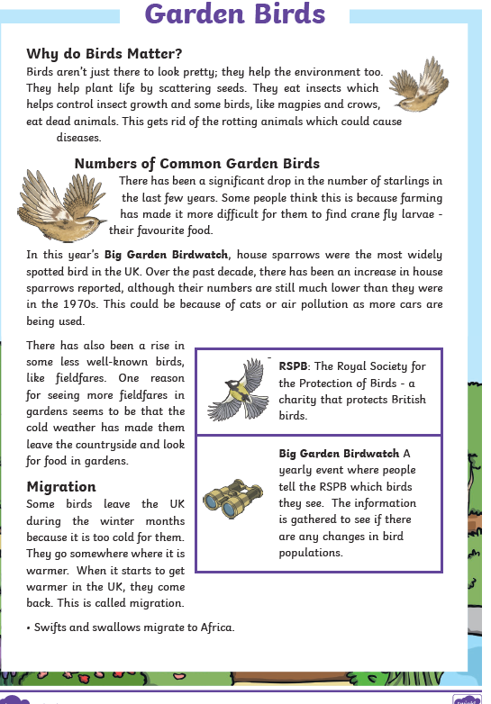

# 

# 

# Lesson 2 English:

# 

# Lesson 3 English

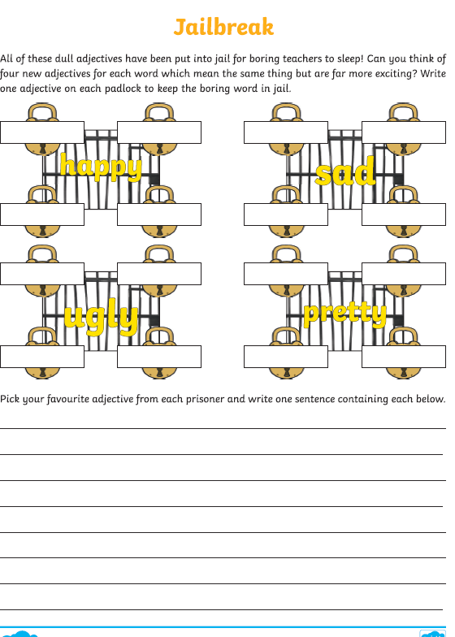

**Lesson 4: These are your spellings for this week**

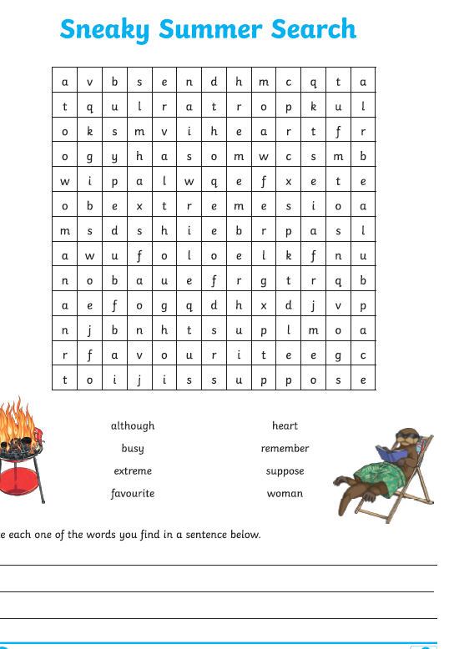

**Lesson 5: Prepositions**

A preposition is a word that tells you where or when something is in relation to something else.

Examples of prepositions include words like after, before, on, under, inside and outside.

**After walking for miles she rested on a hill.**

**In this sentence 'after' tells you when she rested and 'on' tells you where she rested.**

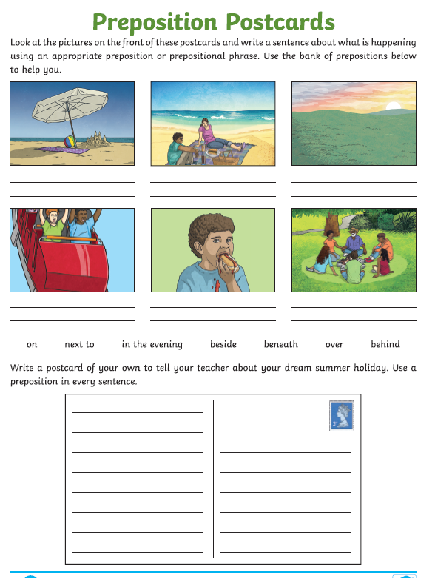

# Maths Topic: Time

**Objectives:**

Tell and write the time from an analogue clock, including using Roman numerals from I to XII, and 12-hour and 24-hour clocks.

Estimate and read time with increasing accuracy to the nearest minute; record and compare time in terms of seconds, minutes and hours; use vocabulary such as o’clock, a.m./p.m., morning, afternoon, noon and midnight.

Know the number of seconds in a minute and the number of days in each month, year and leap year.

Compare durations of events (for example to calculate the time taken by particular events or tasks)

**Lesson 1: Read through the information on the knowledge organiser and complete the first sheet.**

For more information and practise visit BBC Bitesize KS1 or KS2 Time depending on how well you remember telling the time <https://www.bbc.co.uk/bitesize/topics/zkfycdm>

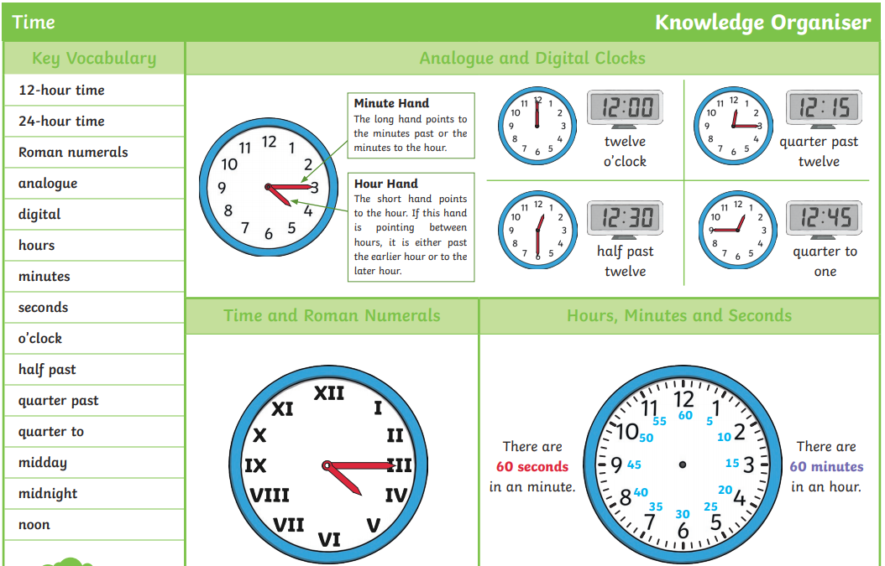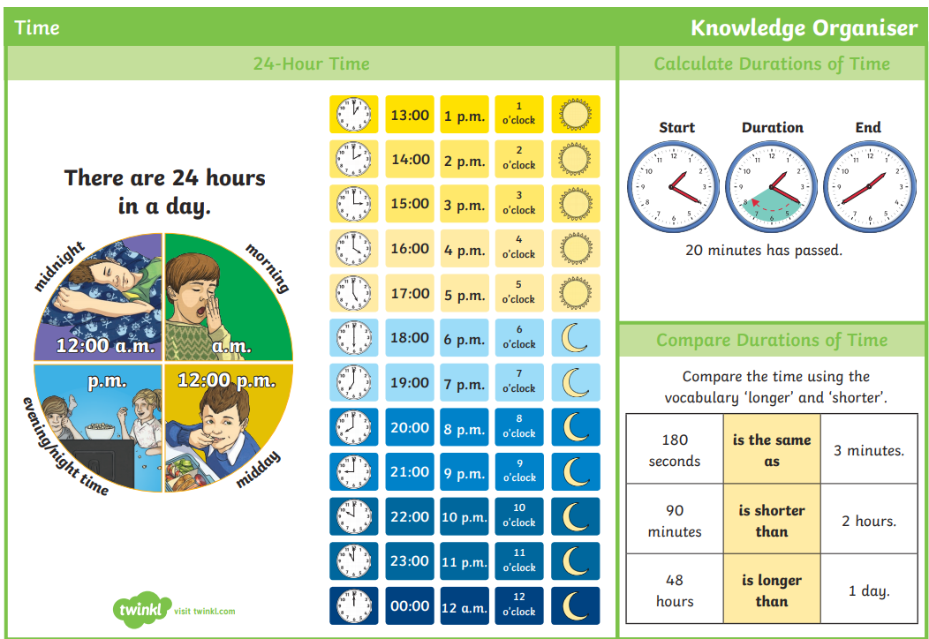

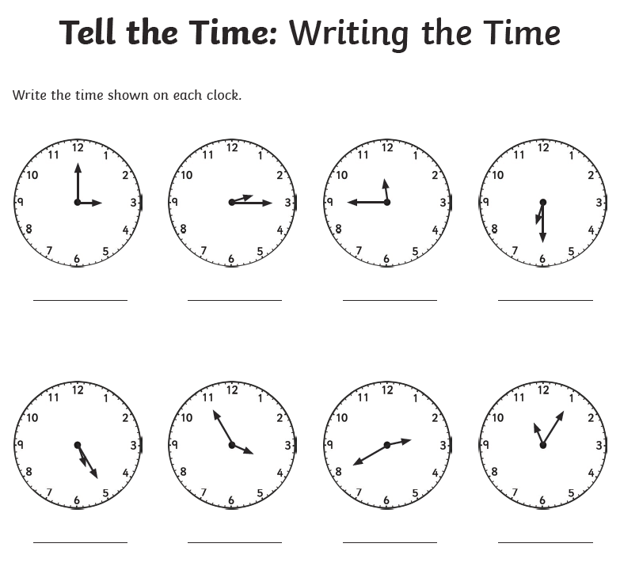

**Lesson 2: Make your own clock with card and a split pin. Wear a watch and keep track of the time through the day. Learn the Roman numerals to tell the time on the sheet below.**

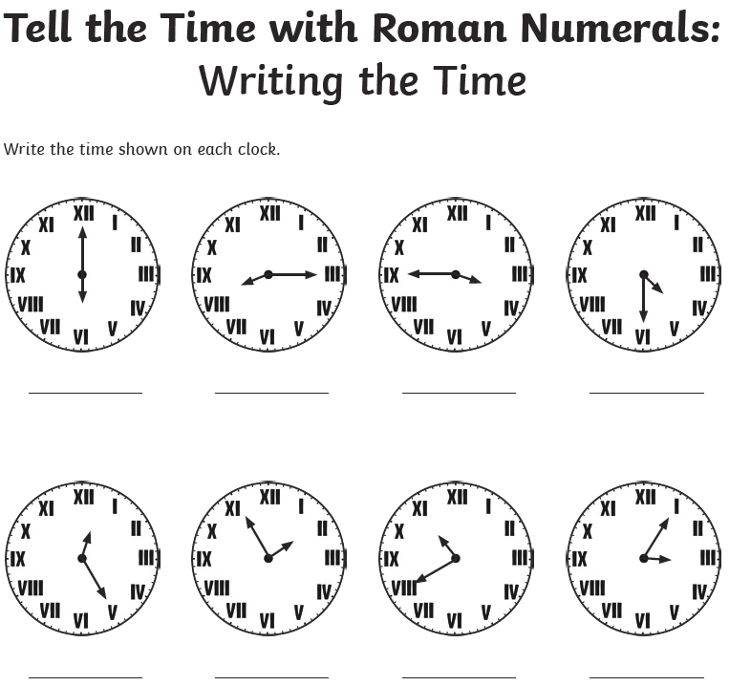

Lesson 3 Look carefull at the times – can you work out the time on each clock.

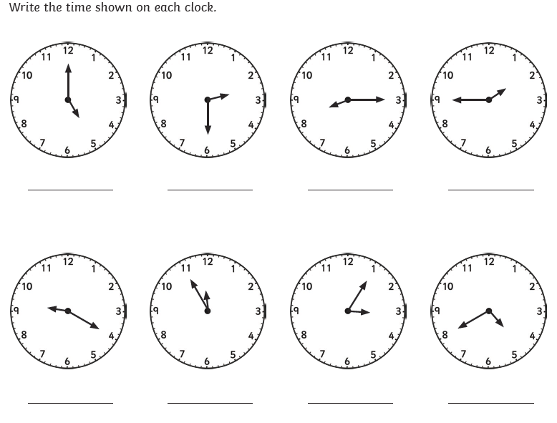

Lesson 4: Can you write the time in 24 hour clock?

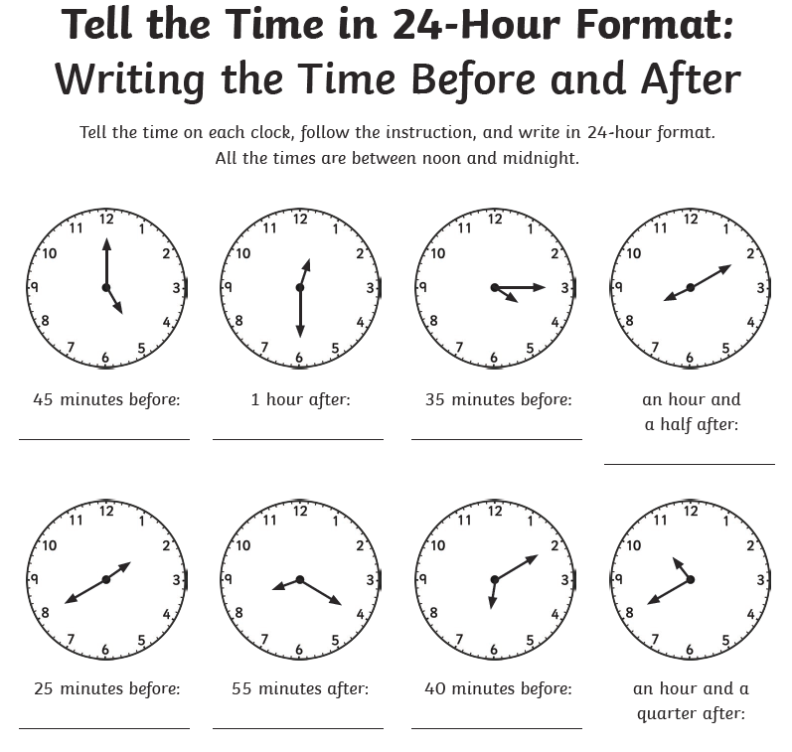

Lesson 5: Practise you times tables today.

# PE

**Outdoor P.E:** Practise your athletics this term. Sprint technique – on your marks, get set, go. Keep your arm tight in your sides and keep your fingers together to cut through the air. Have your own sprint races. Time yourself and see if you can improve on it through the week. Remember to stretch and warm up beforehand and cool down strtches afterwards. Keep drinking plenty of water to keep you hydrated.

**History:**

‘The Living Lockdown Project’ History Project

The Wiltshire and Swindon History Centre in Chippenham has started the ‘Living Lockdown Project’ and is collating an archive showing how our lives have been transformed by the crisis. You can contribute your diaries, stories, poems or photographs. Please visit the website [www.wshc.eu](http://www.wshc.eu) In class, we are putting together a time capsule of evidence from this time. You could make your own Lockdown time capsule. What would you put in it to look at and remind you in years to come.

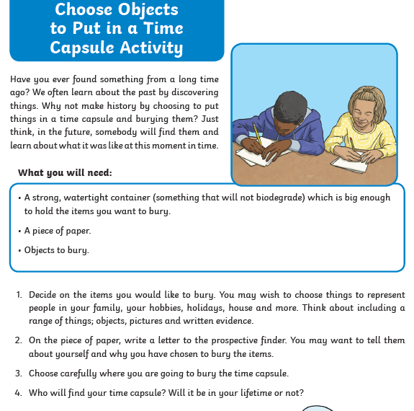

**Science**

**Research your garden wildlife by going out and seeing how many creatures you can spot. Here is a hedgerow spotter sheet to get you started.**

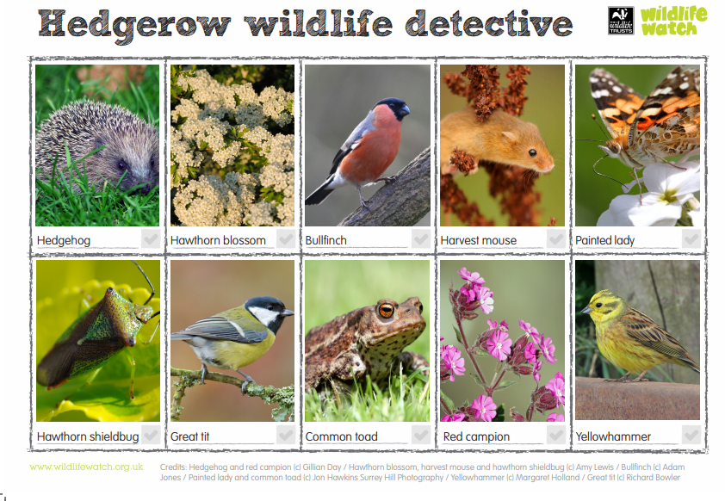

**Then choose a creature you would like to attract and design ways to attract it to your garden or outside space. It could be planting flowers to attract bees or maybe even find ways to attract a hedgehog by creating a safe home for them. Perhaps you would like to entice the birds by making feeders. You could make a bug hotel out of collected sticks and leaves. You can even make a mini pond!**

**Read how to create homes for wildlife** <https://www.rspb.org.uk/birds-and-wildlife/advice/gardening-for-wildlife/creating-a-wildlife-friendly-garden/>

**R.E**

**All year groups**

Last week was Pentecost Sunday and this feast will be our focus for the next couple of weeks.

*What do you already know about Pentecost?*

Make a poster / booklet / short film to show what you already know and can remember about Pentecost.

Use the key questions below to prompt your thinking.

**What does Pentecost celebrate? How does this link to Easter?**

**Think of at least 5 key words that you think link to Pentecost. Why did you choose them?**

**What symbols and images do we associate with Pentecost? Why?**

**How does the Catholic Church mark Pentecost Sunday? (Liturgical colour? Bible reading?)**

**Which sacrament(s) could you link to Pentecost? Why? (KS2)**

**What was the impact of the first Pentecost Sunday? (KS2)**

**What impact can Pentecost have on Christians today? (KS2)**