**Money Puzzles.**

1. **Money Bags**

Ram divided 15 pennies among four small bags.

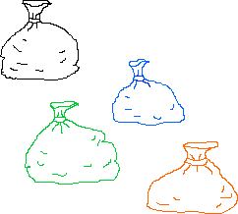

He labelled each bag with the number of pennies inside it.

He could then pay any sum of money from 1p to 15p without opening any bag.

How many pennies did Ram put in each bag?

1. **The Puzzling Sweet Shop**

Rosie went into the sweet shop with 10p to spend.

There were chews for 2p, mini eggs for 3p, Chocko bars for 5p and lollypops for 7p.

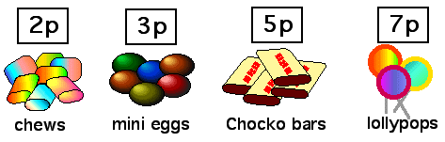

What could she buy if she wanted to spend all her money?

Alice, James, Katie and Henry went into the shop too. They each had 20p to spend and they all spent all of their money.

1. Alice bought at least one of each kind of sweet. Which one did she have two of?
2. James spent his money on just one kind of sweet, but he does not like chews. Which sweets did he buy?
3. Katie bought the same number of sweets as James but she had 3 different kinds. Which sweets did she buy?
4. Henry chose 8 sweets. What could he have bought?