**Good Afternoon Everyone** - staff, children (at home or in school) and parents (at home or work). We cannot believe this is the first week of term 6! Did you enjoy any BBQs in the glorious sun over half term? Maybe some of you had your paddling pools and tents out, while others may have managed a bike ride or two. Whatever you did, we hope you had a lovely half term.

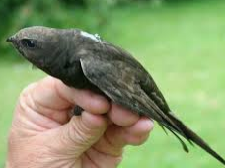**NATIONAL GARDEN WILDLIFE WEEK** Another great reason to head outdoors and learn about the nature on our doorsteps. This week I would like you to go ‘Swift Spotting’. Swifts are flying back from Africa to breed in traditional nest sites, usually in the eaves of taller buildings in our villages, towns and cities. One of the last summer migrant birds to arrive (usually in May) they are among the first to leave (July) so time is short to appreciate these spectacular and mysterious birds. Swifts look quite like a swallow but are bigger and look black in most lights. They are superb flyers that are almost completely adapted to an aerial life, feeding and even sleeping in air! They only need to land to lay eggs and raise their young. Lots of folklore surround these magical birds and it was thought for hundreds of years that they hibernated in mud, until the facts of migration were established. They actually make the amazing journey down to Central Africa and back, covering distances of over 3000 miles in just five days! If you spot a swift, let us know!

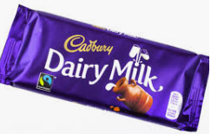**JUNE IS NATIONAL CANDY MONTH** We believe this has come to us from USA, but it sounds fab! June is National Candy Month, established by the National Confectioners Association, and the month of June is used as a way of celebrating the years of sweets and candy production. As some of you will know Mrs Courtney LOVES chocolate and recommends that as well as sampling some sweet treats this month, *remember our mindfulness teeth brushing from Term 5*, you also take a look into the history of our most well-loved confectioners – the Cadburys family. Follow the link below and you can learn all about John Cadbury, who with his sons George and Richard, opened a small grocers shop in Bull Street, Birmingham and started one of the most recognised global chocolate brands! <https://www.cadbury.co.uk/our-story>

**THINGS TO INVESTIGATE ONLINE** Have you heard of John Logie Baird? He is someone who we all need to thank for being the pioneer of the television! On 1st June 1946, television licences were issued in UK for the first time and cost just £2! Have a look at the link to learn about this remarkable Scottish engineer. <https://kids.kiddle.co/John_Logie_Baird>

Martha Washington was born 2nd June 1731. She is known for being married to George Washington, who was the first president of the USA, but there is more to her life as the first ‘First Lady’. Learn about her life here - <https://kids.kiddle.co/Martha_Washington>

We hope you have a fab time swift spotting, eating and investigating!

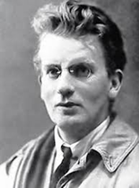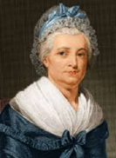 Miss McLoughlin and Mrs Courtney